This document outlines the details of the implementation of a new website called Rothar.info – a website for people that like cycling. Rothar is an Irish word which means bicycle and this website will be aimed at people that like cycling and are based in the UK and Ireland. The report includes details of current and past designs, lessons learnt, technology used and further plans for the website.

**Background**

I have an interest in cycling and have been really excited by some of the new websites and web applications that have been created over recent years – especially the ones which allow users to track their routes and engage with other users through these applications.

I have been living in London for three years now and find that sometimes I would like to go for a walk or cycle but struggle to find an interesting route as I have no prior knowledge of certain areas. I also prefer routes which a circular – that is to say that they are not A to B routes they have the same start and end points however they mostly do not return on themselves.

The plan is to firstly develop a community website based around cycling and to cultivate a website community and a later phase will be to implement a circular route planner. The first phase of this project is to create a website for people that like cycling and to cultivate a community and attract developer that would be interested developing the circular route planner.

This is a project of two websites as my original website [www.revolvingroutes.com](http://www.revolvingroutes.com) was built using the CMS Drupal and I wasn’t happy with how it looked or functioned so I have decided to rebuild the website using Wordpress and have it hosted on a different domain. The current Wordpress version of the website can be found at [www.rothar.info](http://www.rothar.info).

**Short Description (140 characters):**

A website for people that like cycling.

**Elevator Pitch (140 words)**

Rothar.info is a website for people that like cycling and the website will be implemented in several phases. The website development will be spilt into phases and the first phase of the website will be rolled out in iterations and should provide people with an opportunity to add/view events, discuss topics in a forum, add/view local cycle groups, buy and sell items, and read or write for the blog site.

Second phases for the website will aim to introduce a mobile application with GPS tracking and a circular route planner.

The site is mainly aimed at people based in the UK and Ireland that have an interest in cycling - however may attract an audience from further afield or may be split to represent different locations.

**Manifesto**  
To be the go to place for people in the UK and Ireland for people that are interested in cycling.

**Competitor Website Analysis**

This is a selection of competitor websites. As this project is going to be implemented in phases I have looked at a variety of websites.

**Strava**

Strava is a website/phone application, which enables users to use track their exercise activity using the Strava mobile application using a GPS tracker or to manually log their activity details. Users can analyse their results on the desktop or mobile app. Strava is aimed at runners and cyclists and is mainly targeted at those users that are generally more competitive/ serious about exercise. There is a strong gamification element, which means that other users can compete with each other and users can earn trophies for completing a route in the fastest time, times are measured by the GPS system and then calculated by the Strava software.

Screenshot of homepage.

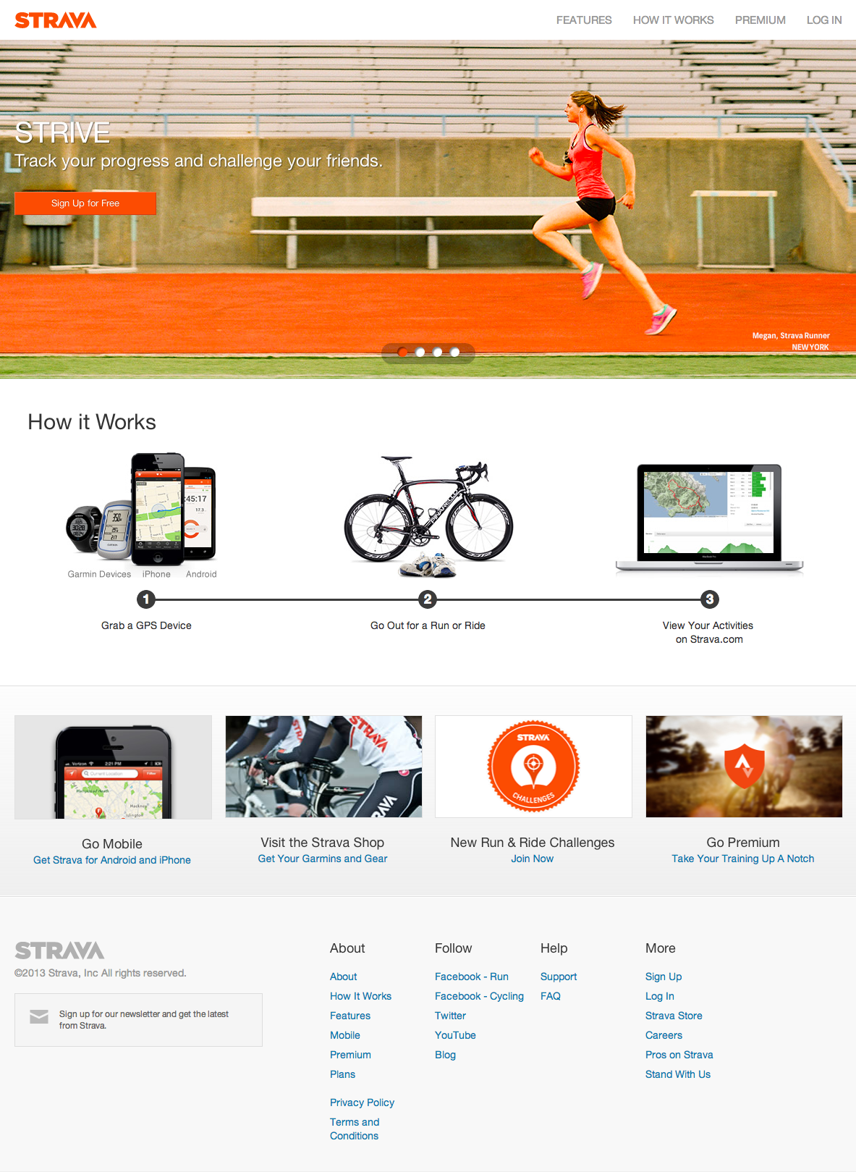

Please see Appendices for additional screenshots.

**Business**

Strava operate under the Freemium model so the website and app are free to use to a certain level. There is no advertising on the website. There is an online shop and the premium subscription is priced at $6 per month or $59 per year. The premium subscriptions unlock additional features.

10% of Strava’s income comes from the online shop and the rest is made up of subscriptions. The company is not yet profitable but Strava has raised $16 million in venture capital (Bike Retailer, 2012).

**Commodity**

The Mobile application is well thought out and easy to use. Competition is a major element of the site. Once a users activities have been logged and uploaded through the mobile app the users can then analyse their workout and compare to other users which have completed the same segments of the route and the application also compares their own previous records along segments encouraging users to not only compete with other users but also themselves. Upon logging into the website the user is requested to join a challenge – encouraging competition between users. The application is constantly encouraging users to connect with friends too – further encouraging competition.

Segments can be created by users and then when any user is on that path. Users are awarded trophies depending on how well they have done on a route or segment: for example a user can win personal best trophies or compete against other users to win best time on that segment.

Strava hold various challenges such as ‘King of the Mountain’ where users compete against each other to be the fastest to get up the mountain while tracking their time using the Strava GPS tracking application. There are not usually any prizes linked to these challenged but the user will receive additional ‘badges’ or ‘trophies’.

Local cycle groups have started using Strava to conduct their weekly cycle so users to not congregate at a physical location on a specific time. They link up with the cycle groups via the app. [Windrush Triathlon](http://www.windrushtri.com) Club in London is a Triathlon club that also has Strava profile so members of the triathlon club can see what others users activities are and compare their times and speeds over certain courses. Their route builder, which is in Beta, has lots of good options for creating routes. Screenshots of this have been included in the appendices. Strava has an online shop where they sell Garmin products.

**Delight**

The website is clean and clear. As a used of this site I find it a joy to use. The user is not overloaded with information but there is plenty there to explore if the user wants. The website and application are very well thought out and the colour scheme of white and orange represents the fact that they are for more performance driven athletes well. The imagery used in select places also back this up – I especially like the use of imagery on the sign up/login pages. Their badge/trophy/challenge icons are also very well suited to the site.

They use the word ‘athlete’ throughout the website.

**Firmness**

It is likely that Strava is built on proprietary technology with iPhone and Android apps that are linked to the users account, which can be accessed by desktop. Strava uses Zendesk as their customer support portal. Strava uses Google Maps for their map tiles.

**Map my Run/Ride**Map my run is probably the biggest online map/tracking website/application that there is. According to an article on [Bike Retailer](http://www.bicycleretailer.com/north-america/2012/06/07/fitness-apps-storm-cycling#.UlGSzWRAR60) the is aimed at a broader range of people than Strava and “has amassed 8.5 million users in the past six years, and 25 million downloads. At one point, the app attracted 1 million users in 47 days. MapMyRide alone has about 2.5 million users. This article quotes Robin Thurston, CEO of MapMyFitness saying, “Numbers grew 500%. Another article on Newsle.com [1] states that over 300,000 workouts are logged every day. They currently have over 16 million[2] users.

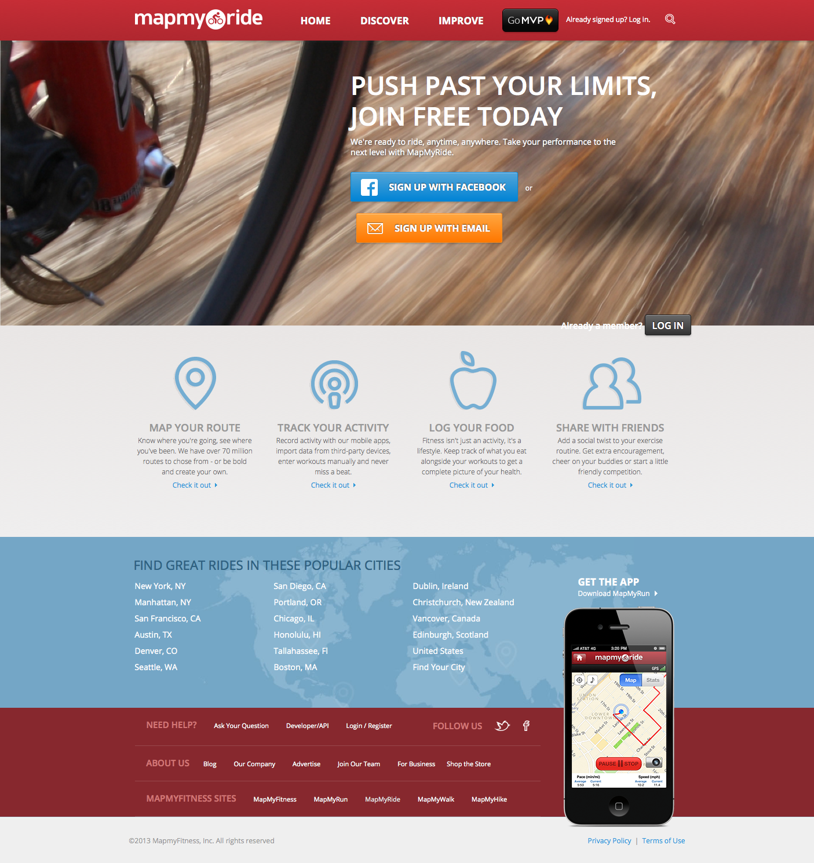

**Business**

This website operates a Freemium model and have various premium options. One premium option is an annual membership for $269, which includes a GPS unit for syncing routes to your account. Other options can be paid monthly $5.99 or annually $29.99 and unlock additional functionality such as Route Genius – which is a circular routing program. I have included a screenshot of the Route Genius in the appendices.

**Commodity**

The users can choose which map tiles they want to use to display the route. By default the map tiles are served by [CyberCity](http://www.cybercity3d.com/) in partnership with Google Maps. Other options for users are to request the OpenStreetMap tiles that are served by [MapQuest](http://www.mapquest.com/)[3].

The mobile app has a GPS tracking which allows users to log and analyse their workouts. MapMyRide send users of the app push notifications advertising their premium services. There is a calorie tracker where users can set goals and monitor their calorie intake. The website has a store where they sell relevant products. Like Strava they do invite users to participate in challenges.

**Delight**

The website is very friendly looking which makes it feel accessible for people of all levels. It’s uncluttered and the app is very easy to use. The workout activity pages are clear and easy to analyse. It’s a very nice website.

[**BikeHub.co.uk**](BikeHub.co.uk)

BikeHub.co.uk is a joint initiative of the Bicycle Association and the Association of Cycle Traders. Bike Hub is a voluntary national Levy system.

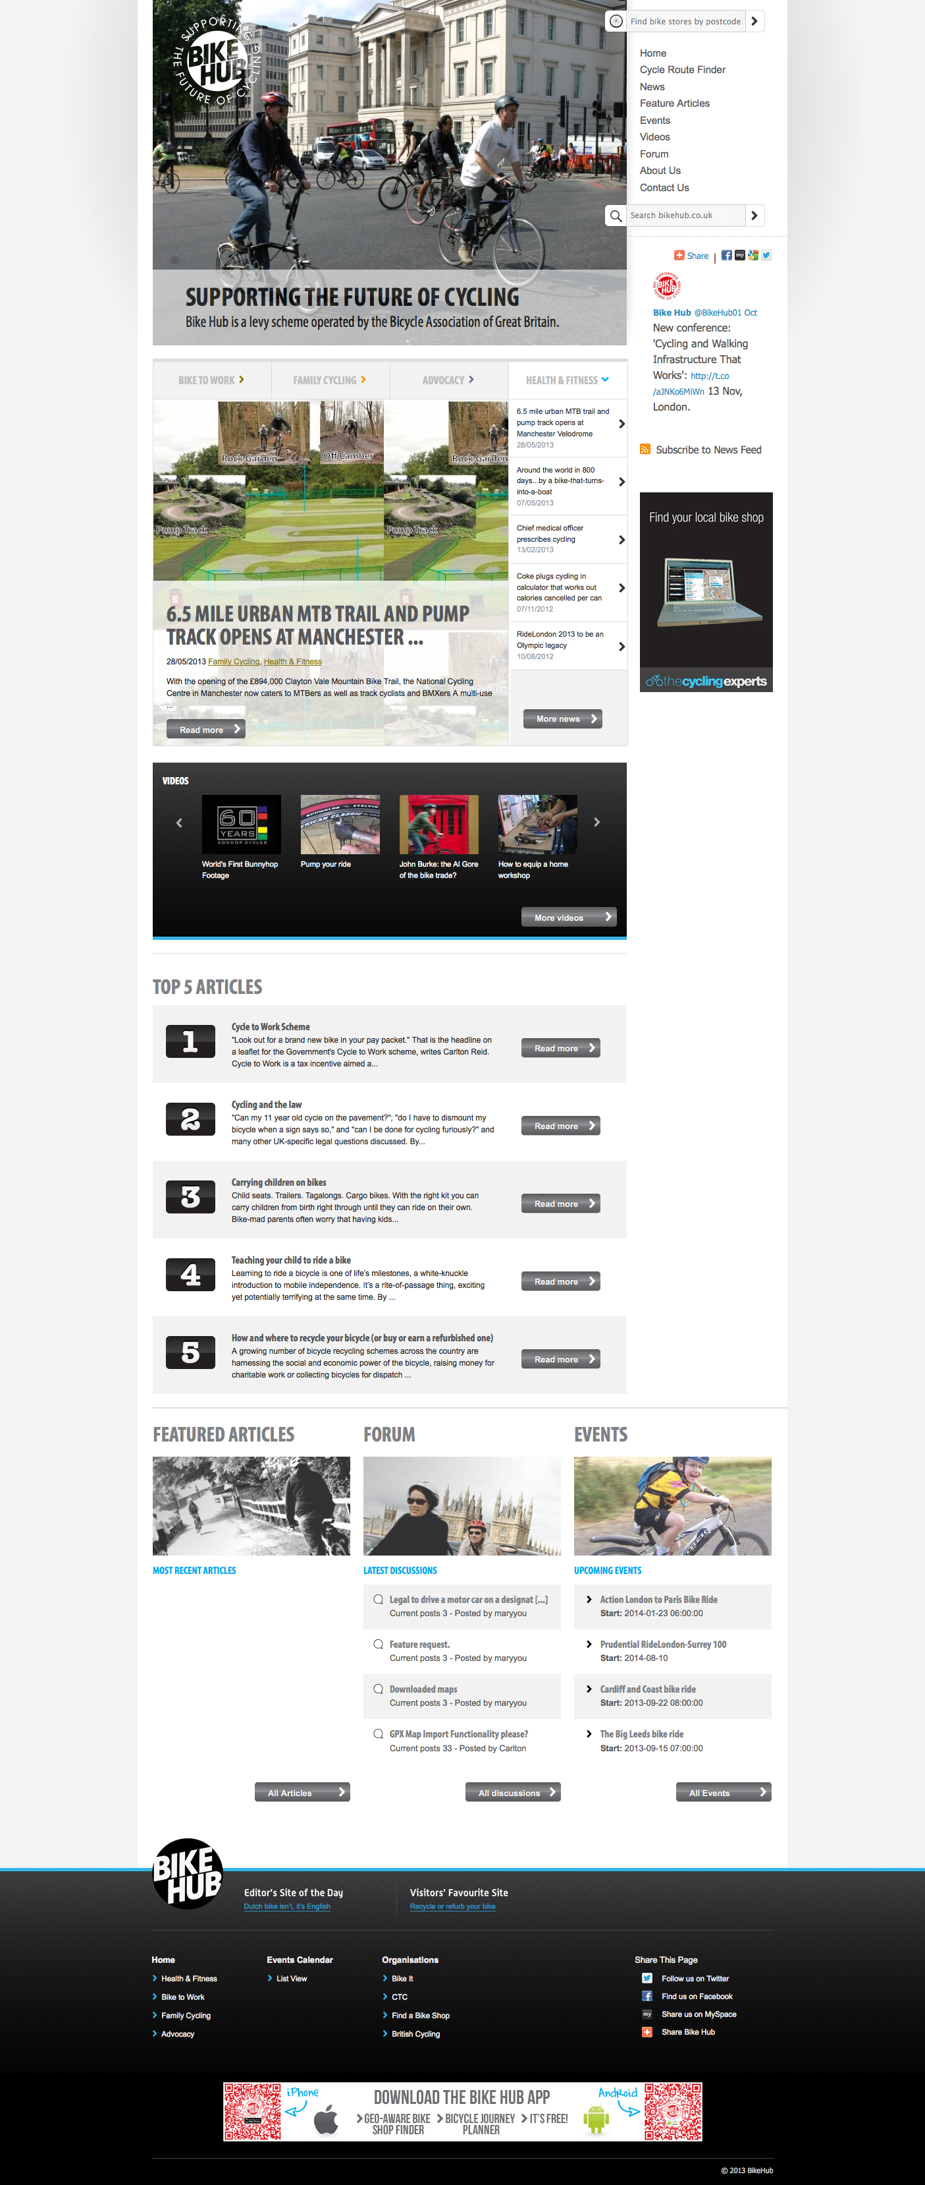**Business**

This is a website for an industry-wide levy applied to the bicycle industry. The levy is paid on a voluntary basis. It’s not clear if the website which are advertised on the website are partners or if they are paid adverts.

**Commodity**

Has a forum and Event listing, which don’t feature very prominently. Forum isn’t overly active. At time of checking the website only has two events listed which are in 2014. Information provided on cycling and encouraging people to take up cycling.

**Firmness**

Users can log in to add events. Website is built using Wordpress CMS. Not responsive. Mobile applications that are available for download to iPhone and Android.

**Delight**

The website is nice however I find the visual hierarchy difficult to digest and it’s not overly clear to me what it is that Bike Hub is trying to emphasis or call attention to.

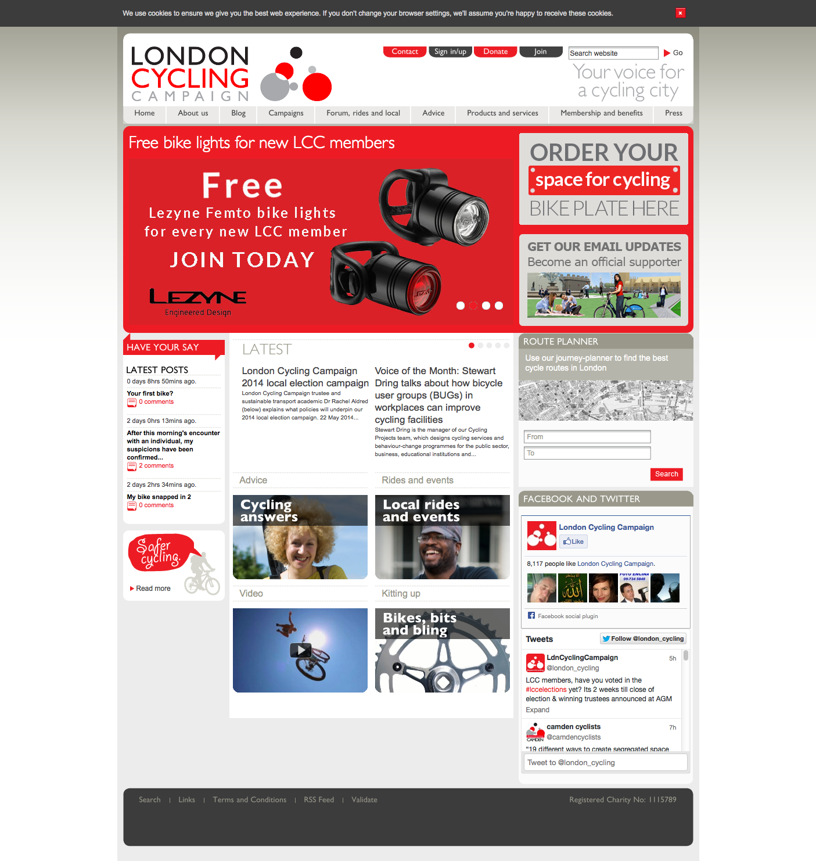[LondonCyclingCampaign](http://lcc.org.uk/)

This is a website for the London Cycling Campaign which is a registered charity promoting cycling in London.

**Business**

The purpose is to encourage users to sign up for memberships and to inform and engage current members.

**Commodity**

The forum isn’t overly active. There is a route planner. Campaigns section. Event listings: map and list view.

**Firmness**

Website is built using transitional HTML. Route planner powered by [Cycle Streets.](http://www.cyclestreets.net/)

**Delight**

It is clear from logging on to this website that the main aim is for them to get users to sign up for a membership There are a lot of menu options and there is a lot of information being packed into the pages which can make it confusing to new users.

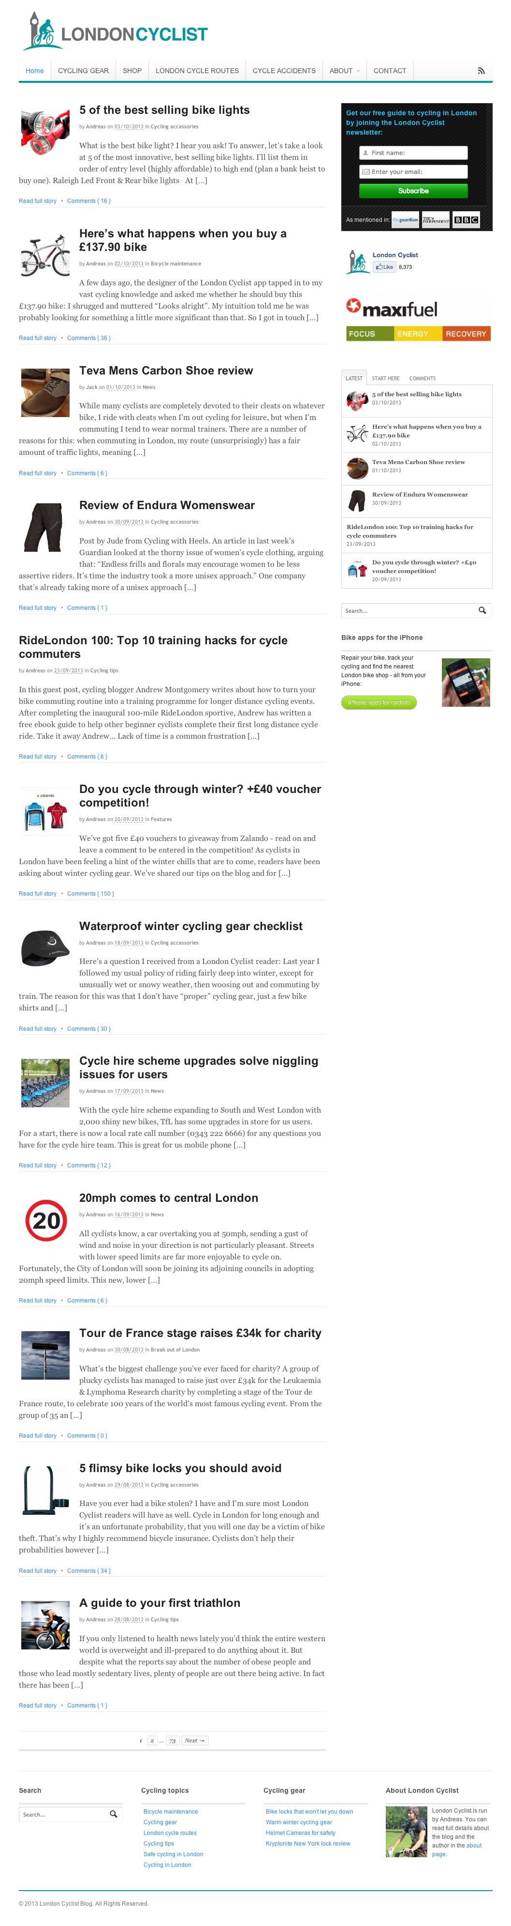[LondonCyclist.co.uk](http://www.londoncyclist.co.uk/)

This website is a blog which discusses various topics relating to cycling and cycling in London. The blog has been going since 2007.

**Business**

Andreas, the person that owns and runs the blog site, has written an e-book which is for sale through the website. According to the website there are just over 5,000 subscribers to the weekly newsletter and the book has been downloaded 1,239 times and at £9.99 would mean a turnover over £12,000. One of the main navigation items is a promotion for cycling accident management services from a company that help cyclists that have had accidents to make claims. There is a shop on this website however I wouldn’t be sure how much it is in use. There is space on the homepage being used for advertising. I get a weekly email, which is informative, and I enjoy reading. There are competitions and promotions in the emails. This website ranks quite highly in Google searches and it seems to be quite popular. There are affiliate links with Wiggle and Amazon.

Additionally the London Cyclist has created a Bike Doctor App which according to the website has been downloaded jus over 12,000 times and costs $4.99 which is a turnover of turnover of $59,000 if each of those downloads was a full purchase.

**Commodity**

Good articles and reviews. London Cyclist is a respected authority on Cycling and Cycling in London. Has a loyal following.

**Firmness**

Built using Wordpress. The website is responsive. The e-book shops take payment through PayPal and are managed through [e-junkie.com](http://www.e-junkie.com/).

**Delight**

The website is quite plain and simple which works well as it is a blog. I found some of the pages quite text heavy and found that I didn’t really read a lot of the text. Clear call to actions with 'Buy it Now' buttons and 'Call Me Back'.

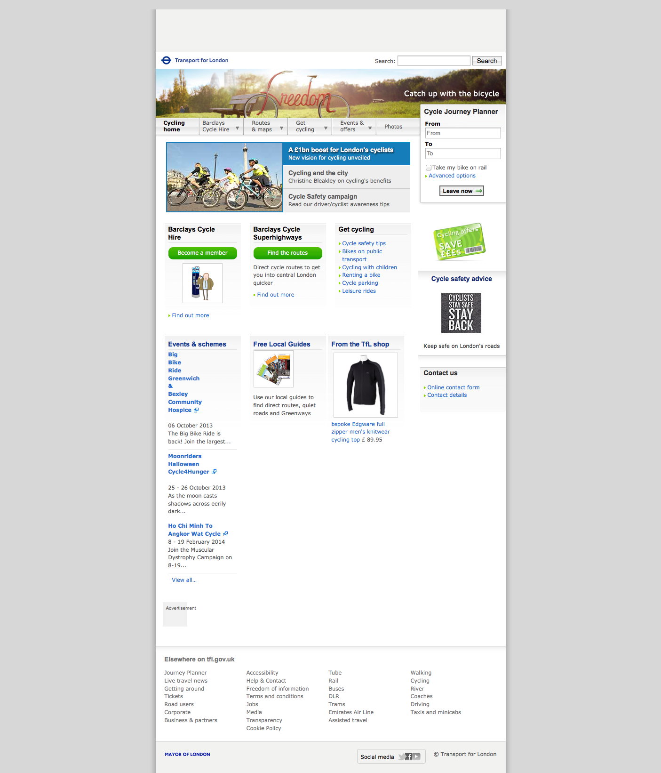[**TfL**](http://www.tfl.gov.uk/roadusers/cycling/11598.aspx)

Transport for London is a Government body responsible for most aspects of the transport system in Greater London. Their cycling pages feature quite highly in Google searches relating to cycling and routes.

**Business**

Surprisingly as I didn’t notice this before (I have used this website many times) the TfL cycling website has a cycling shop. I am uncertain as to what the policies are around a government body acting as a shop. There is information about the Barclay’s Cycle Hire scheme which they are using this section of the website to promote. Free local guides and promotion of cycling in general

**Commodity**

As this is a Government Body website the website needs to be highly accessible and adhere to strict standards. It’s not responsive but does serve a mobile version of the website.

**Firmness**  
XHTML 1.0 Transitional. I assume it’s a custom built CMS.

**Delight**

This is ahighly functional and clear website. It’s accessible, clean and easy to navigate.

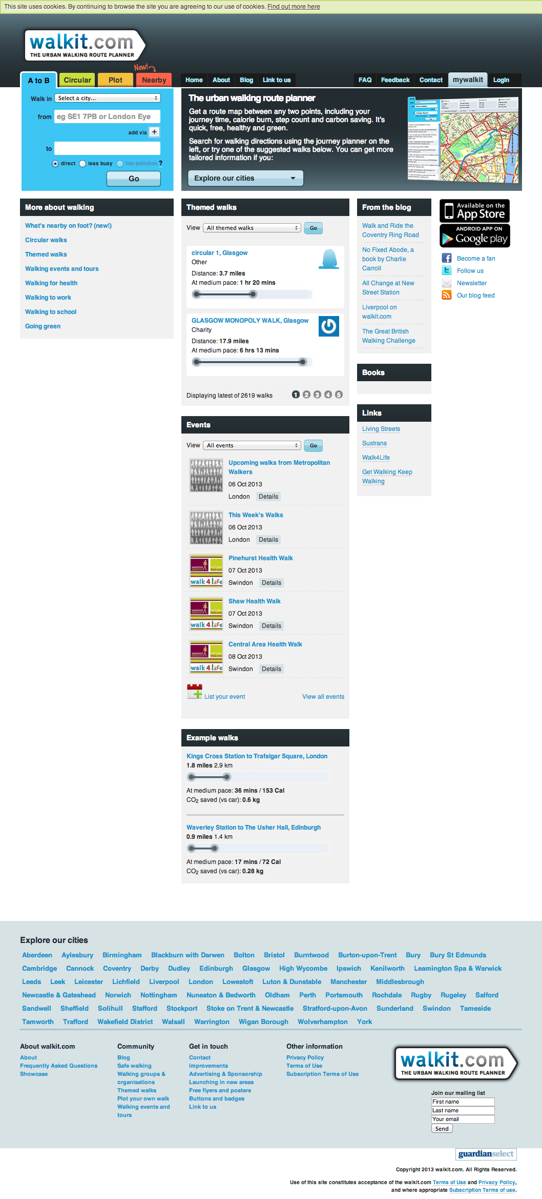

[Walkit.com](http://www.walkit.com)

**Business**

Walkit.com Operates a Freemium model so users can purchase a walkit.com membership to access additional features such as the ability to create more than one circular route from a location. The option to sign up for a premium account is a bit lost because a user has to click into the website quite a lot before they are told that they can buy a membership. There is no obvious call to action on the homepage for this.

Walkit.com has an Android and iPhone app available for purchase which features quite prominently throughout the website.

After additional investigation (again there was no immediate call to action) I noticed that this website offers location based advertising to companies where the routes pass the location of the business and they have their prices starting at £15 per month. They do place a call to action at the top of routes but I must have suffered from [banner blindness](http://www.nngroup.com/articles/banner-blindness-old-and-new-findings/) (Nielson, 2007) or maybe I just ignored it because it’s not relevant to me.

**Commodity**

This website does circular route planning which is something which I would like to develop for rothar.info at a later stage. The circular route planning on the walkit.com website is quite straightforward: the user selects their city, enters their location (although UX could be improved by removing the need to enter the city), how long in time from 15 minutes up to 4 hour and the pace at which you want to walk. Once the user submits this information then the circular route is output on a map with a hill profile and some additional information such as distance, calories used, time taken at different paces, print and share options. Over the last few years the website has been adding locations to the route planner and now Walkit.com covers a lot of places in the UK but their route planner only covers the area that they have listed.

Users can add walking events to the listings and the listings need to be approved by the website administrators. The website has a widget which allows websites to link their own location on the website and walking instructions to/from there. Walkit.com have linked to a media pack that lists the stats and demographics of their users which is a useful reference and benchmark. Excerpts form the media pack have been included in the appendices as these might be relevant to future business plans.

**Firmness**

This site is built using Wordpress CMS Android and iPhone app available. The website is not responsive however they have phone apps for the site. I have used the website many times and always find that I am on desktop before I start planning a walk. Maps are supplied by [Navteq](http://www.navteq.com/), which is a Nokia owned mapping company, and the routing is powered by proprietary system called [Drawllive](http://www.drawlive.com/) which was built by walkit.com.

**Delight**

This website is reasonably clear and functions well – although there are a couple of user experience elements which could be improved and they could make it easier for potential users to sign up. There are two separate menus on the homepage and the separation of colours for different menus works well and it’s clear which menu they want to emphasise.

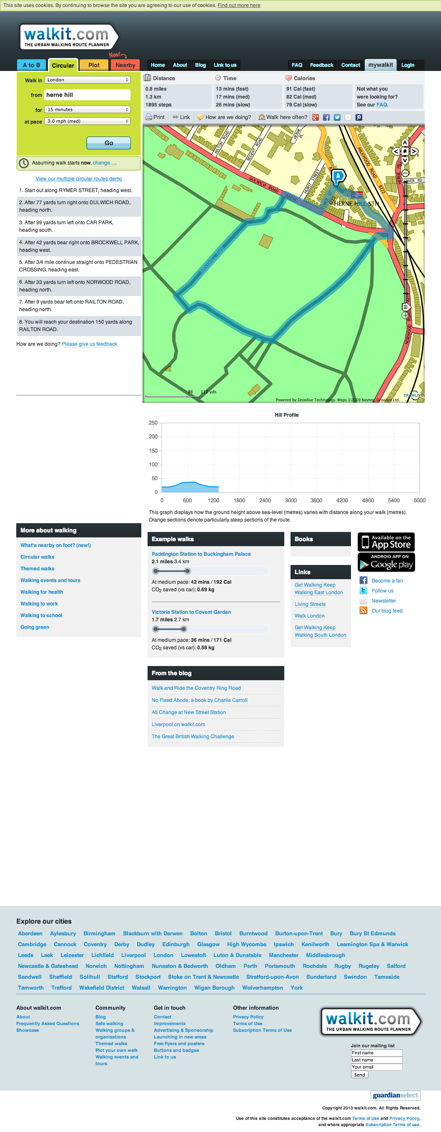Screenshot of the walkit.com circular route planner.

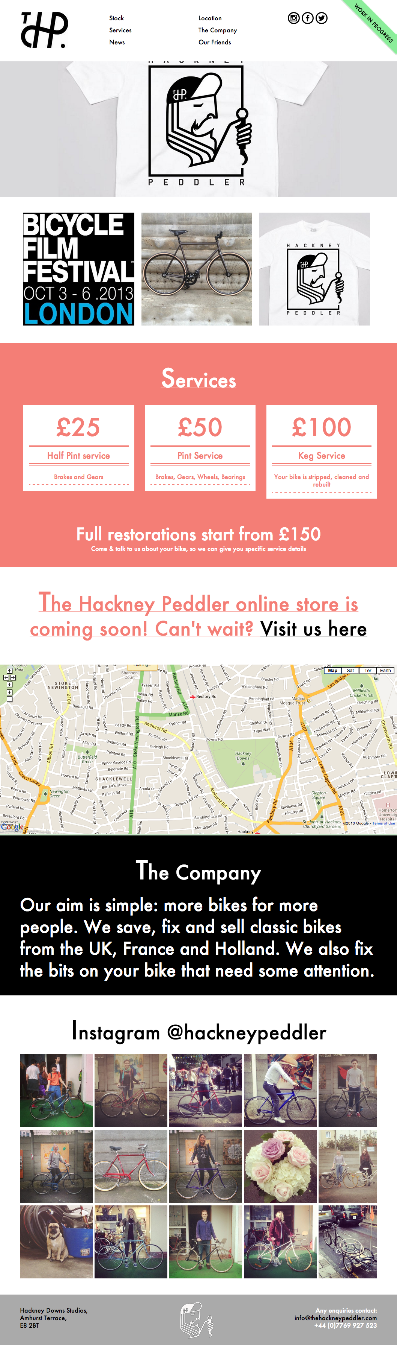[The Hackney Peddler](http://rothar.info/)

This is a website for a bike shop in Hackney which refurbishes bikes

**Business**

The Hackney Peddler uses this website to advertise their bike shop and bike servicing. There is an online shop coming soon.

**Commodity**

This website’s purpose is mostly as brochure ware but they also promote local events of interest and try to cultivate an image an interest in refurbished bicycles.

**Firmness**

The Hackney Peddler uses a CMS called [Process Wire](http://processwire.com/), which I had not heard of previously. According to the Process Wire website “Process Wire is designed to have an approachable simplicity that is retained regardless of scale. Simplicity often implies reduced capability, and this is not the case with Process Wire. From the surface, there is very little complexity and the application requires no training. “.

At time of writing the website uses Facebook listing for the bikes that they have for sale however they have advertised that an online shop is coming soon.

**Delight**

Very nice and bright – visually balanced one page website. It’s clear what the Hackney Peddler is trying to call your attention too. I like their use of the instagram feed which contains pictures of happy people with their new bikes that they have purchased from the shop.

**Design Inspiration**

A selections of websites and graphics which provided design inspiration.

[Gantoli](http://gantoli.bigcartel.com/)

I love the layout and use of colours on this website. Their brand features prominently and the main focus is on the products. The Gantoli logo is prominent and the navigation is secondary to the products which I think works very well for this website.

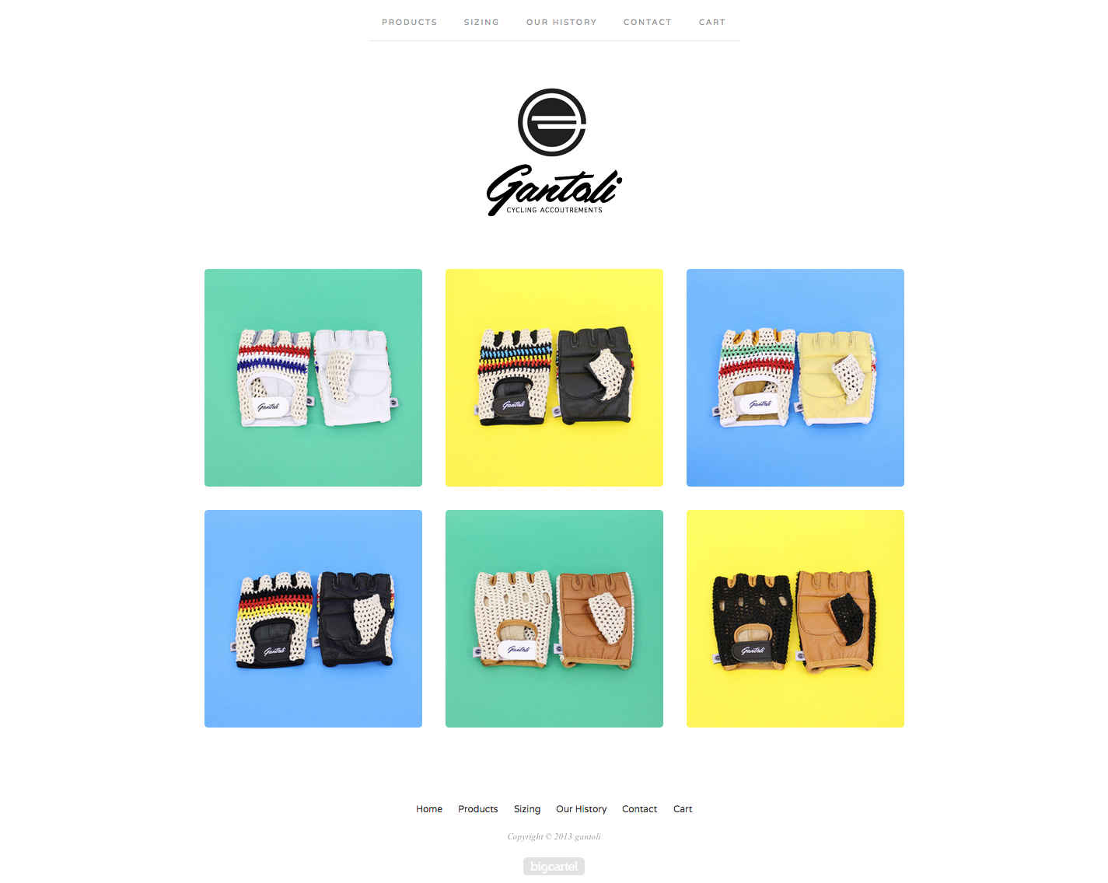

[**Lock 7**](http://www.lock-7.com/)

Another website which I really liked was the website for Lock 7 Café. Again, I liked their use of colours and imagery. The website has a strong colour to represent each tab on the navigation and the images are very strong.

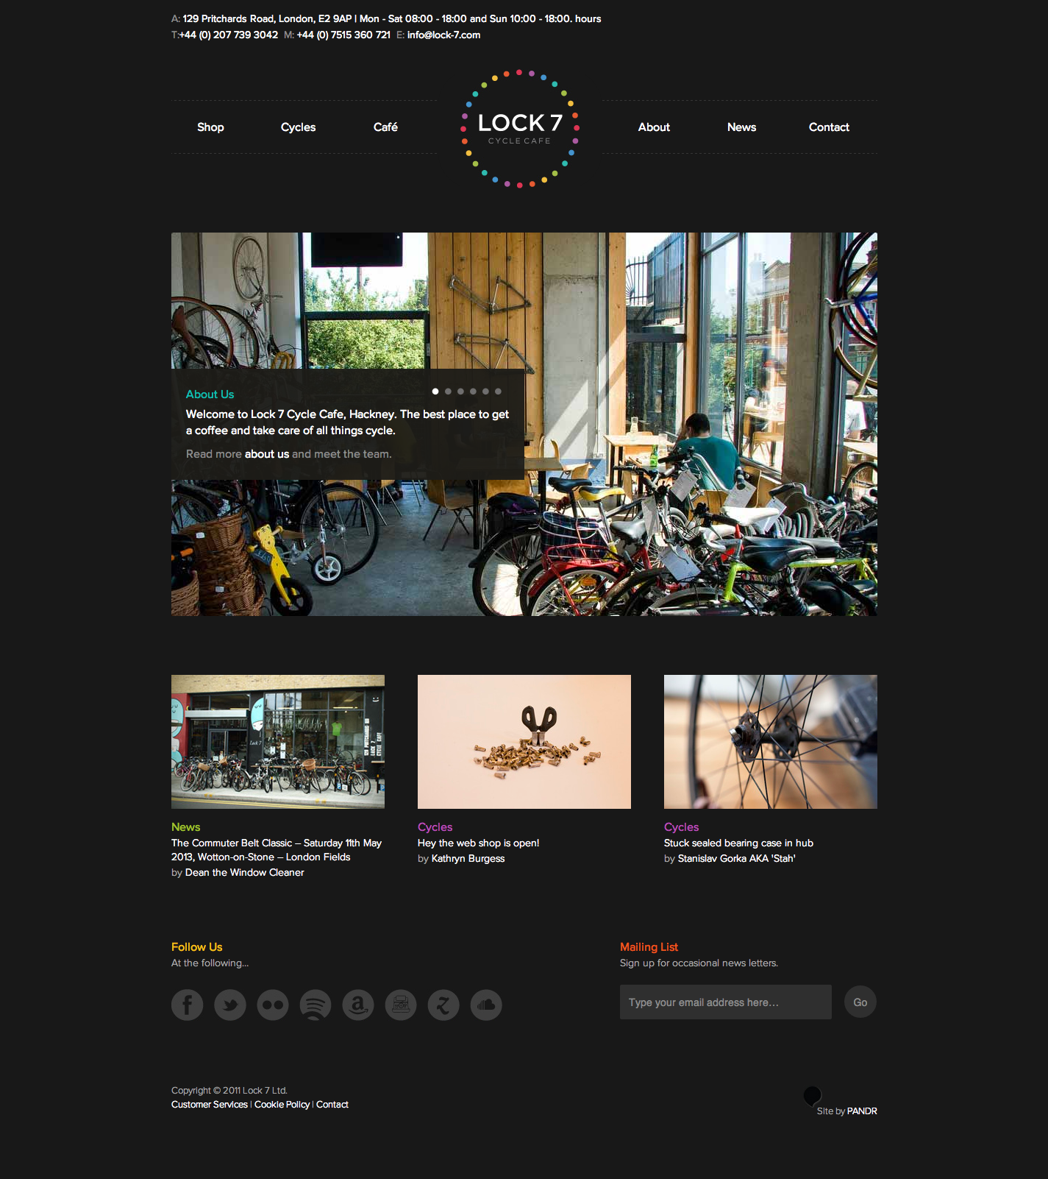

[www.bricklanebiles.co.uk](http://www.bricklanebiles.co.uk).   
Note the use of a badge style logo and laurel.

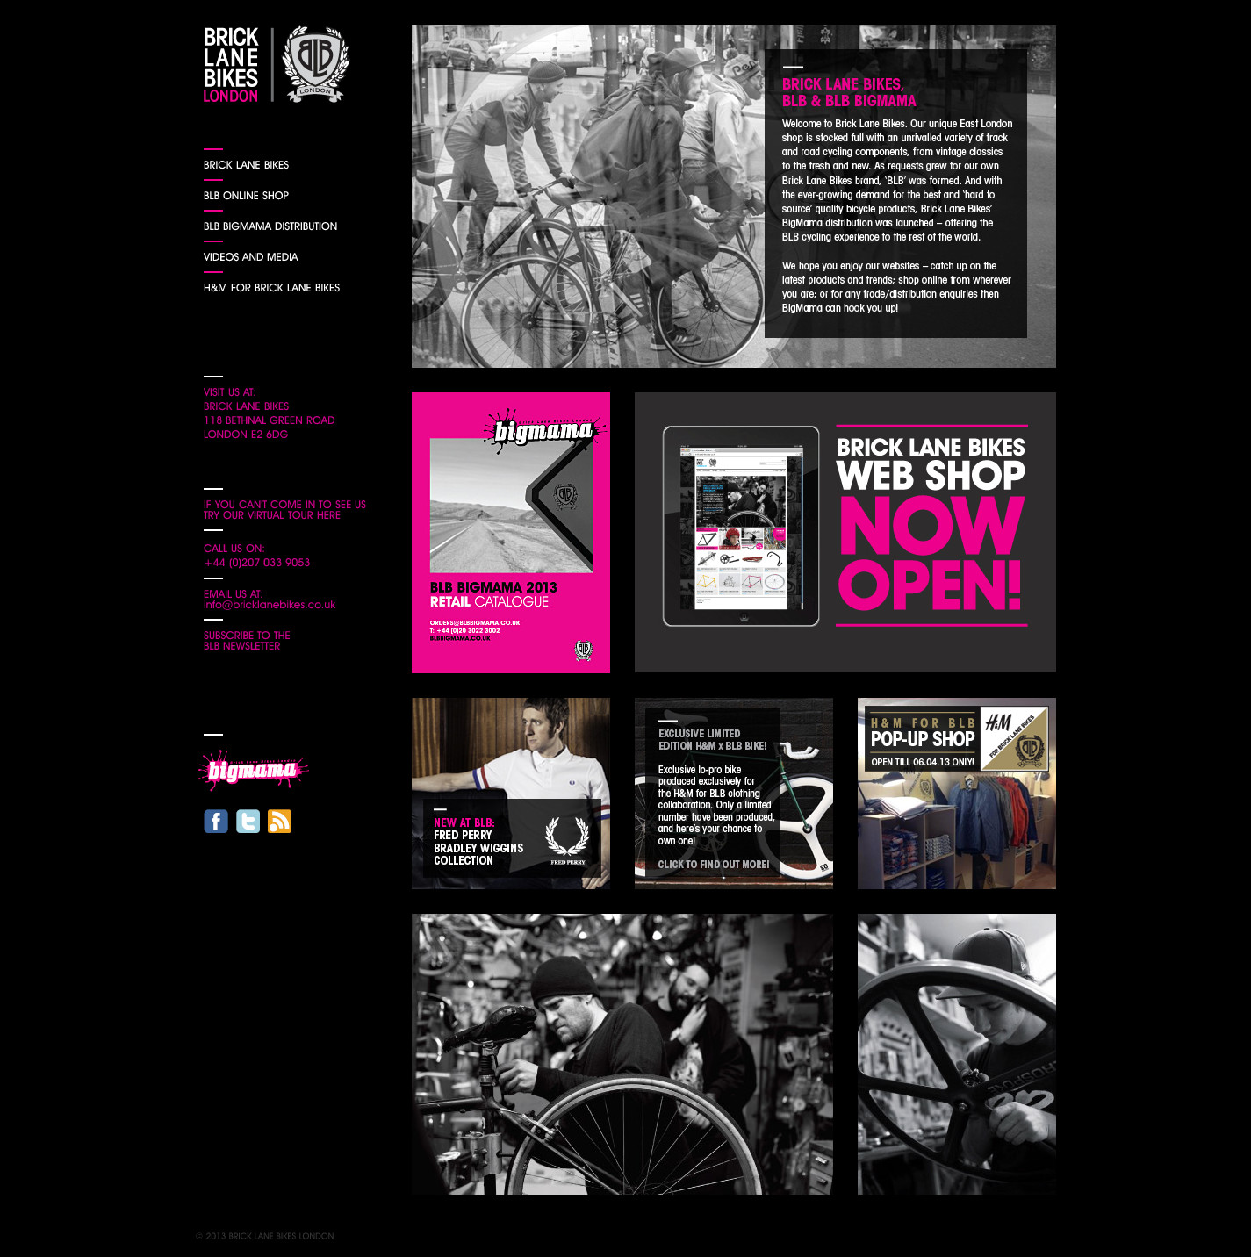

<http://www.chargebikes.com/>   
Bright light website with strong full width visuals.

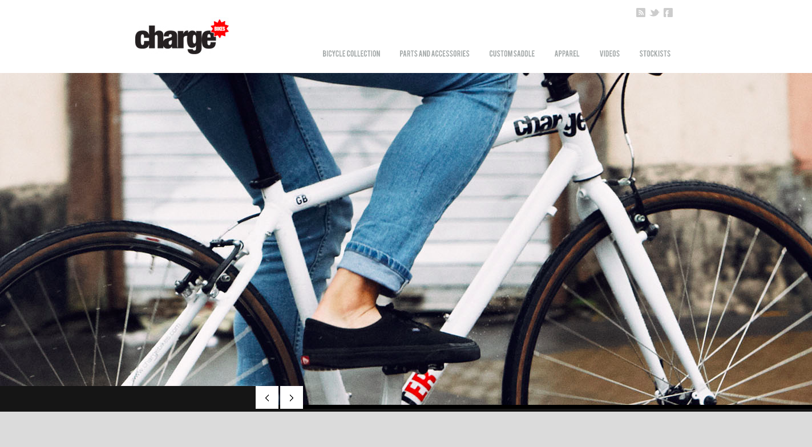

**Login pages for Strava and MapMyRide**

Big impact images with black transparent boxing overlay.

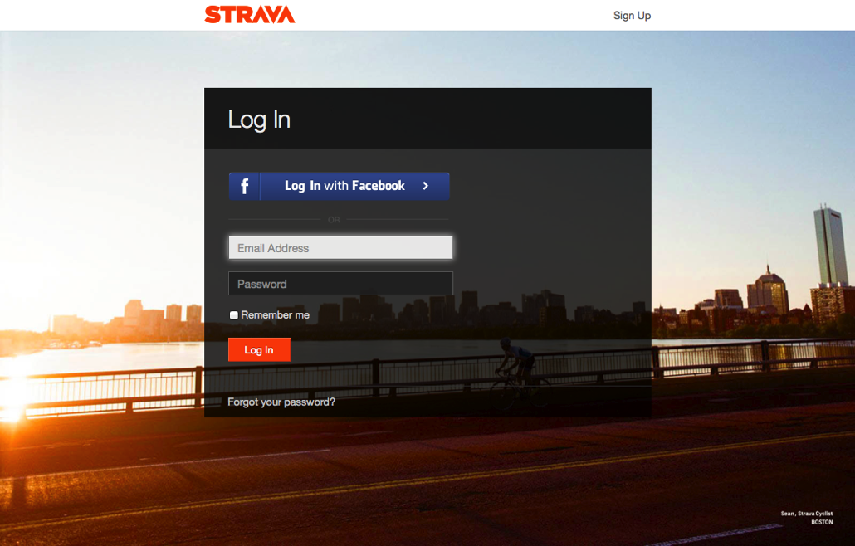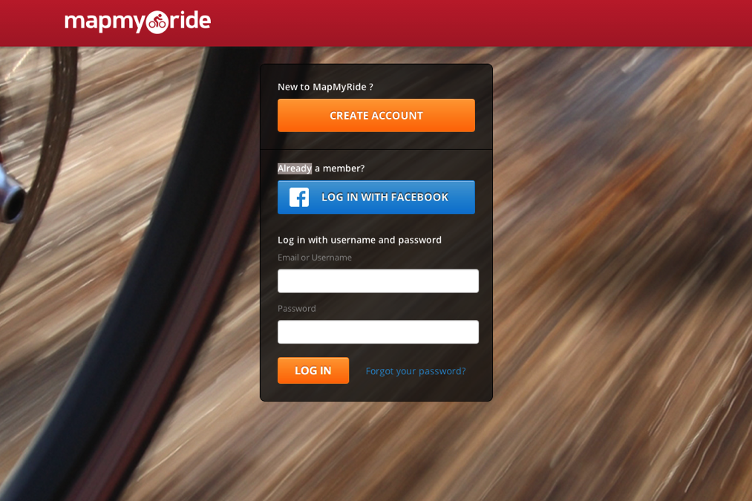

**The name**

The original name for the website was revolvingroutes.com however for this stage of the website the routing part isn’t going to be integral to the website so I decided that it would be better to rebrand as rothar.info. Rothar is the Irish word for bicycle and the name will scale well for future versions of the site because in English the word alludes to the word rotary and the word in English is not tied to cycling in any way. However I am aware that this name may cause problems with the audience based in the UK and have not as of yet been able to test the UK users reaction to the name and this can be built into user feedback forms.

Some domains which are available and might be considered if Rothar.info does not work for the UK market:

|  |
| --- |
| * upstroke.co.uk |
| * frontwheelie.com |
| * backie.co.uk |

**Design**

The design of this project was an iterative process and some elements were quite intertwined. I have tried to describe the design process in logical steps below.

**Logo**

For the logo design I wanted to emulate a brand badge style, which can be seen on the front stem of bikes such as the Raleigh image below.

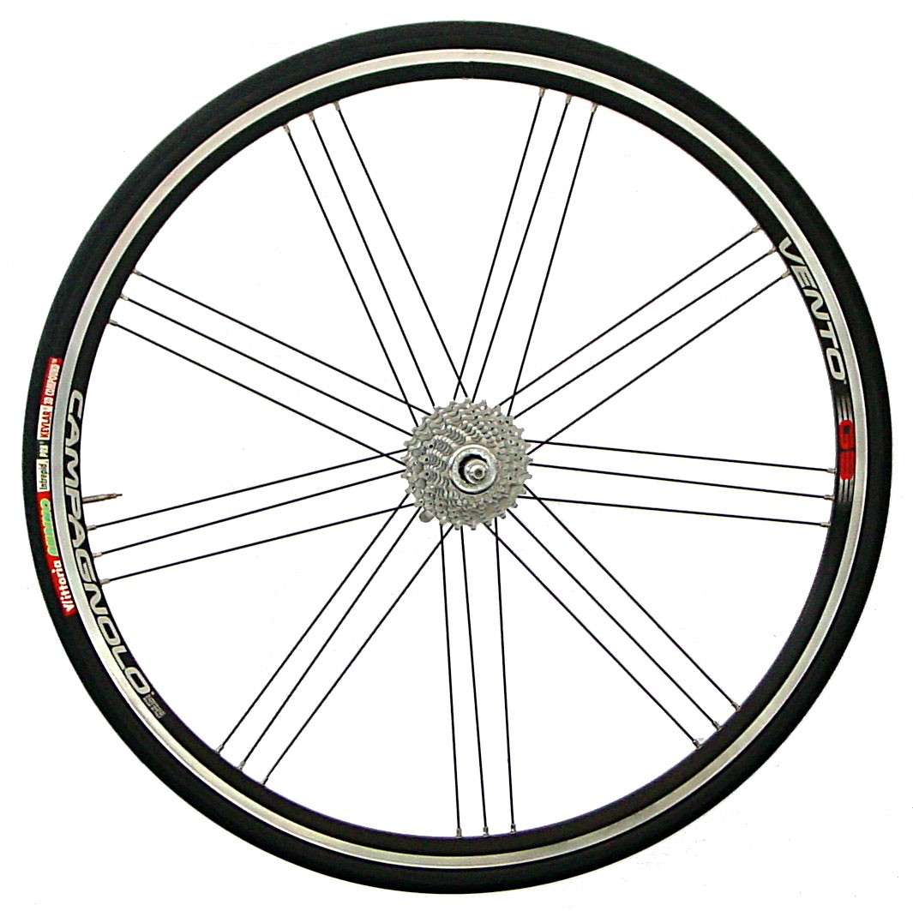

I started with a circle, which is inspired by a bicycle wheel. At first I wanted to include the text around the circle of the badge. I decided to use the laurel is an opportunity to bring some colour to the logo and to give a hint of the outdoor element of the site by using green.The logo designs were originally designed to be on a white/light background.

Logo 1: putting the text into the badge was too constricting and the text was difficult to read.

Logo 2: the center of logo wasn’t very coherent.

Logo 3: incorporate a bicycle into the logo however some feedback was that this was excluding walkers or runners and could impact on future versions of the website.

Logo 4: this incorporates footprints into the logo therefore keeping the branding inclusive for the walkers and runners.

1 2 3 4



Adding the text to the top and bottom of the logo was making it too tall and that was making the top banner taller. I also decided that the website was going to have a dark banner so the logo was going to sit on a dark background. In logo 5 below you can see that I switched the colours and the green doesn’t stand out very well anymore.

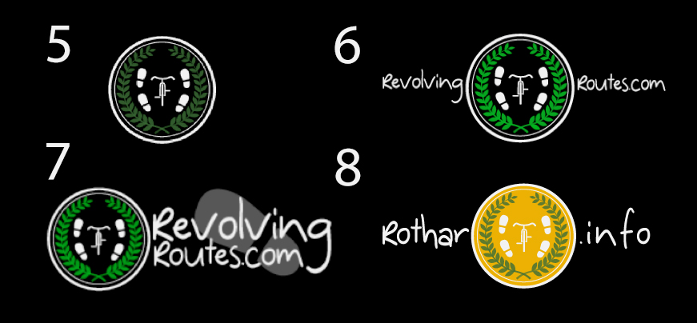

The layout of the navigation changed slightly from the original design (which I will talk about later) and I no longer wanted the logo to be centered in the navigation.

Logo 6: I boosted the green so it stood out better on the dark colour. The original name, revolvingroutes.com, for the website was quite long so I though that this was throwing the balance of the website so moved the text in Logo 7 to the right. To try and balance this logo and to add interest I added in the footprint. For the [www.rothar.inco](http://www.rothar.inco) version of the website I changed the inside of the circle so that it’s picked up the yellow – as this website didn’t use as much yellow I think this now balances the visual element quite well. The text also balances better because it isn’t as long.

For the most parts I was fairly clear on the detail of the logo and roughly how I wanted it to look however I did start one more design, which is below. I got some feedback and in general people were more positive bout the original logo so I didn’t develop this any further.



**Images**

As a starting point I took some photographs so that I could pick out colours from the images that were going to be integral to the design of the website.

To avoid any complications with copyright I took the main images that are being used in the website. I wanted the photos to be very colourful and be aspirational (in that they made people want to get outdoors and explore). After I took the photos I realised two things – firstly that I took too many portrait layout photographs and really I needed landscape only pictures. Secondly that there was too much detail in a lot of the pictures and these would have been better with less detail so that it would have been more visually pleasing to layer transparent black boxes with text over them. For future photos I would also make more of an effort to demonstrate that these photographs were taken in the city – possibly by including the brick wall behind the wild-flowers or by showing that the ferns are actually in a walled garden.

 

**Layout**

I had an idea of how I wanted the website to look and taking on feedback from the design critique I started by drawing up some sample layouts. I was also relatively aware of the restrictions of designing for Drupal, which was the content management system I chose to work with.



**Typography**

**Headings & Tag Lines**  
I want the website to feel warm and welcoming so I wanted to find a nice friendly, fun handwritten font to use sporadically throughout the website for taglines and any appropriate headings.

I originally wanted to emulate and identify the font that was being used on <http://www.wrglive.com/> which I have put a screenshot of below. As WRG live used an image to put this tag line on their website of the font I couldn’t find out. Dafont.com have a forum where you can post images and people will attempt to identify the font however I didn’t get any response from my post.



So I tried various font combinations and the best free font that I decided to use for the headings and tag lines was once from Dafont.com called [Dinosaur](http://www.dafont.com/dinosaur2.font). This font is a great friendly font however at some sizes I found it difficult to read so I added letter spacing of 2px.



**Paragraph Text**

For the paragraph text I wanted to use a simple contemporary, sans-serif font – it needed to be highly legible and I wanted it to be contemporary and modern while still feeling friendly. I identified the following fonts, which suited the requirements are: [Droid Sans](http://www.fontsquirrel.com/fonts/Droid-Sans), [Mueseo Sans](http://www.fontsquirrel.com/fonts/Museo-Sans) and [PT Sans](http://www.fontsquirrel.com/fonts/PT-Sans).

For the Drupal version of the website I chose Droid Sans as the paragraph font.



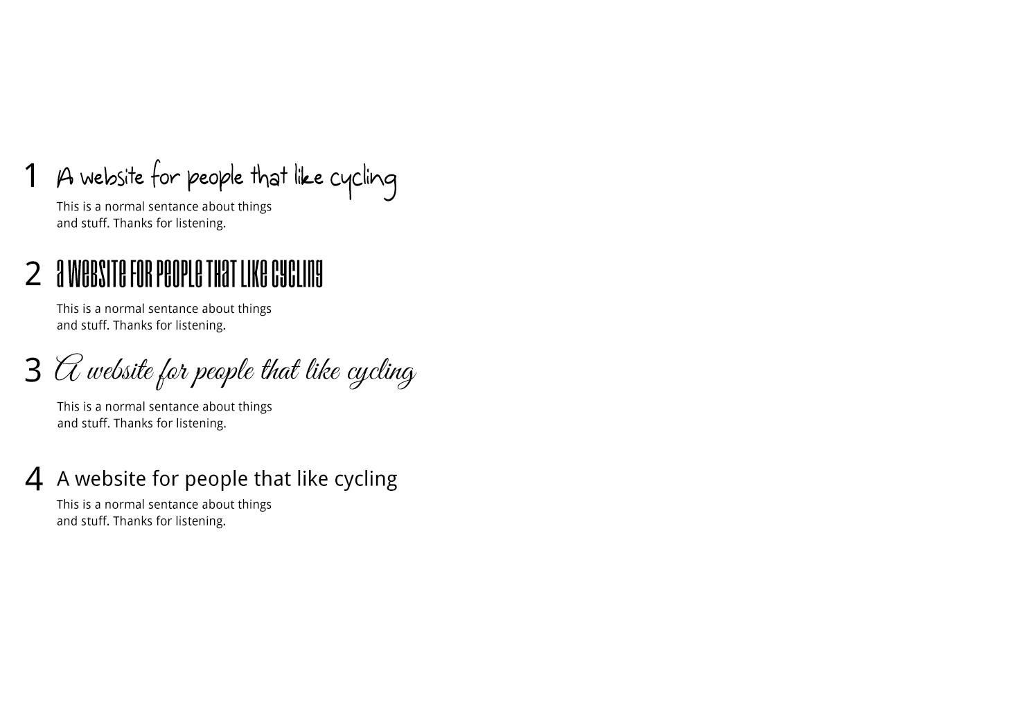

For revolvingroutes.com I selected Driod Sans as the paragraph font which is a free to use humanist font which has been designed specifically for on the screen display.

The busy pictures are quite distracting so for this reason on my Drupal Installation I decided to remove the background images and change the transparency so that the text layers were full block colours. This then led to me using bright colours in the text.

I put together some style tiles which comp and quickly

There is a sample of an incomplete style tile below.

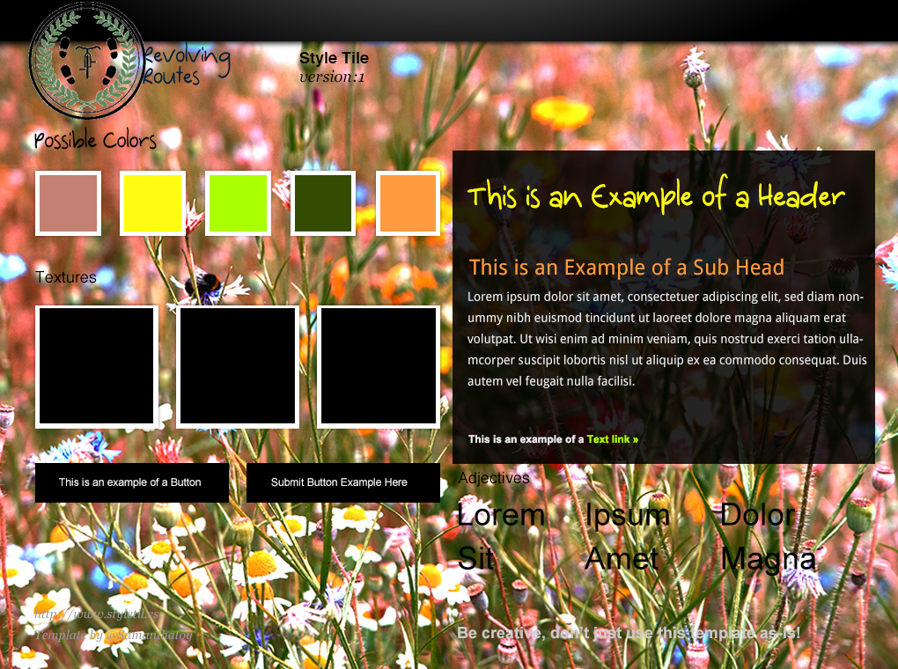

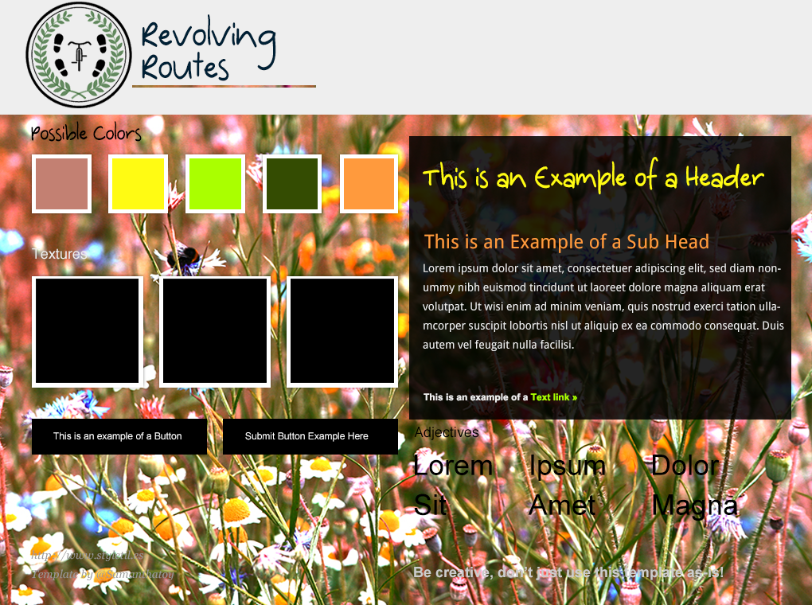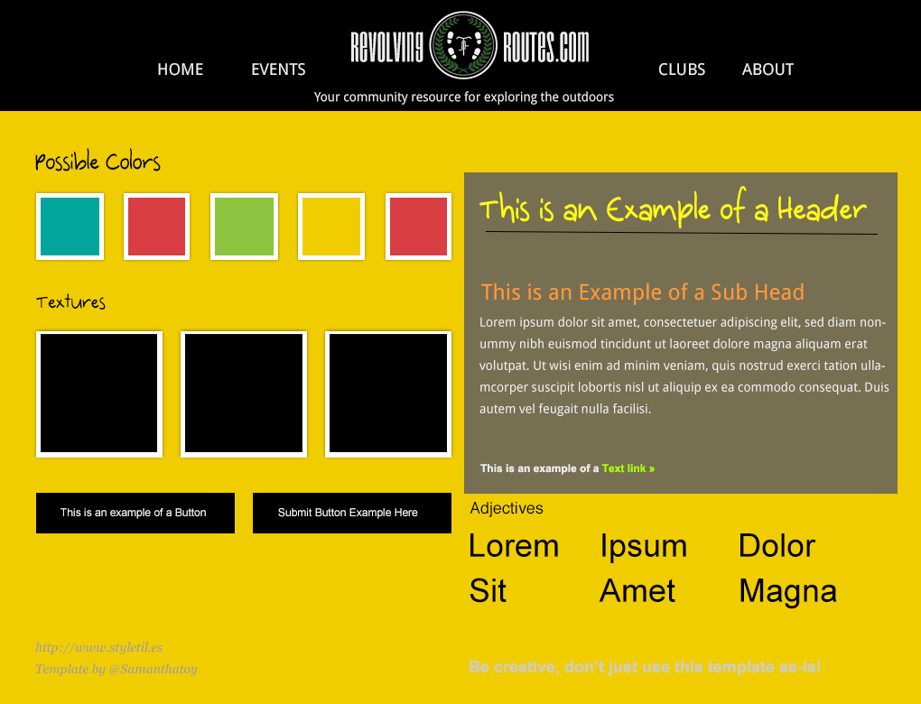

However I had read articles that advised designing for Drupal in photoshop can cause problems (Amanda Luker, 2011) The original concept was for a design with strong background imagery layered with dark transparent text boxes.

I made these style tiles after I had chosen to use Zen as a base for the Drupal design. I decided it would be more beneficial for me to design in the browser (Andrew Searles, 2013) as I had understood that using Drupal as the CMS could mean that I would have to adapt my design later.

**Navigation**

My original plan was to have the logo centered as a list item in the navigation.

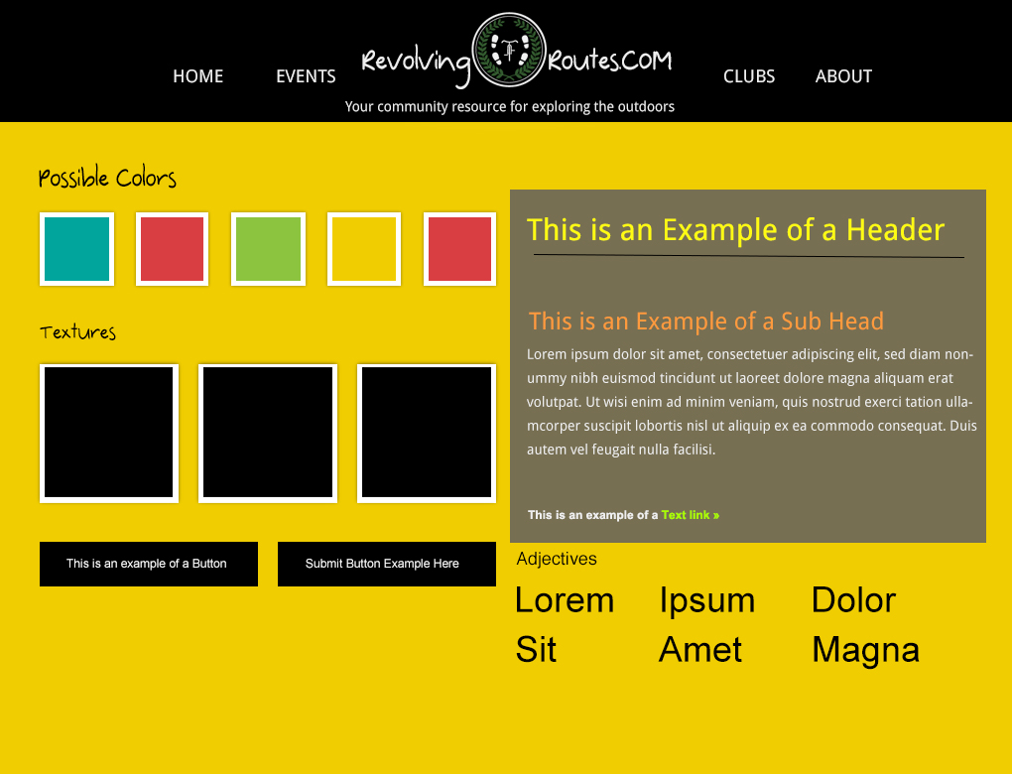

**I put together the HTML**

**Icons**

The icons used in this project are Font-awesome. Font awesome is an icon set that was built by twitter. This icon set shops with twitter bootstrap and can also be used independently. For the first (Drupal) version of my we

I also looked at Entypo, which is a very nice icon set.

**Colours**

The colours I chose for the website changed somewhat from conception to delivery. As discussed my original vision for the website was for the background images to make up much of the colour on the website so that the text. I also felt by using the large background images to supply all the colours I wasn’t really using any colours that are strongly linked to cycling, which is what I originally wanted to do.

**Yellow** is a colour has been long associated with cycling. The Leader of the Tour de France wears a yellow jersey to indicate that they are leading the race [(Wikipedia)](http://en.wikipedia.org/wiki/General_classification_in_the_Tour_de_France).

 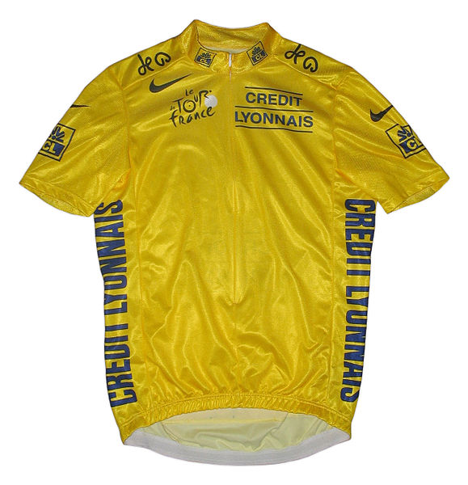

**Other colors to make up sections of highlighting in the website**

The [Union of Cyclists International](http://www.uci.ch/) (the world governing body for sports cycling) uses the colours in the badge below to make up their logo. Add according to [rapha.cc](http://www.rapha.cc/blueredblackyellowgreen) “It was the Olympic games which originally conceived the colours are known as the five colour hoops as they represent Africa, the Americas, Asia, Europe and Oceania, the white background symbolising peace.”

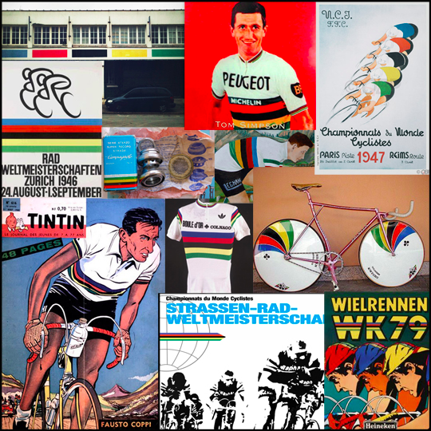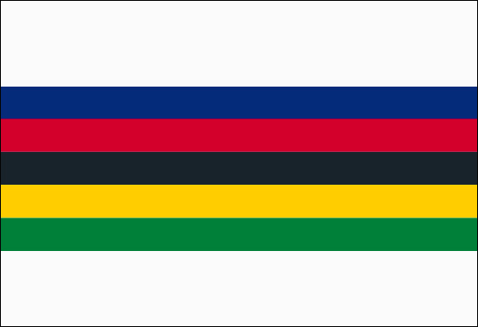

**Main Background Colour**

On my Drupal installation after deciding that the large full-page background images weren’t working to create the look that I wanted and that I needed to re-take new images before they could fit in I decided to go for a dark background colour

**Responsive Text and Images**For text that is responsive the site will use ems as the units for defining text size (and margins, padding etc.) and the technique outlined in [Richard Rutter’s](http://clagnut.com/blog/348/) article which sets the body font-size to 62.5% which changes the body text size to 10px which makes the mathematics a bit easier when applying ems to elements. There are difficulties with using ems as the size it inherits is relative to its parent so dealing with nested elements can be a bit tricky.

CS3 has introduced a new unit called rem would be a better option there is not sufficient browser support at this stage.

“The em unit is relative to the font-size of the parent, which causes the compounding issue. The rem unit is relative to the root—or the html—element. That means that we can define a single font size on the html element and define all rem units to be a percentage of that.” (Jonathon Snook, 2013).

Image widths and objects (for video embedding) will be set to max-width: 100% so instead of the images/videos rendering at their native width/height so it won’t over flow its container (Ethan Marcotte, Fluid Images). There is generally good support for max-width now at 94.3% according to canisuse.com.

**Vimeo for video hosting**

Vimeo was selected for the video hosting as that mean that I don’t have to convert the files into the various formats – Vimeo will automatically convert them for me and they will host the video so I don’t need to worry about the storage on my shared hosting package. For video I would need the following formats available: m4v and .ogv.

Additionally my videos will be freely available to everyone so there’s no need for me to restrict access by hosting them – plus having the hosting on Vimeo (or youtube.com) should help with promoting the website and SEO.

**Mailchimp**

**BBpress**

**Business**The first phase of this project will aim to cultivate a loyal user audience that have an interest in cycling. Users can come to the website to read interesting articles on cycling and connect with each other through the forum. There may be adds on the blog pages and on some of the inner pages of the website however it is not the main aim of the website to make money - this might change over time as there is the potential to launch an online store which sells fashionable cycling gear.

**Promotion**

This project will be promoted using social media and existing cycling communities. There will be blog posts, guest blog writers, cycling product reviews and general bike chat which will improve SEO and also encourage visitors to return to the website. Quarterly emails will keep users connected with the website and encourage return visits.

**Advertising**

On the Blog and Forum section, once there is a reasonable user base, I will implement some advertising for clients. I don’t intend to pay money to advertise rothar.info.

Location wise, in the early phases, the community promotion of the website will be focused on London and Dublin only but this could open up to various locations and communities from there. There would be the option to translate this website into additional languages however that is not for this phase.

**Costs**

So far the set up of the project has cost as follows (this does not include the purchase of books and access to online tutorials)

|  |  |
| --- | --- |
| Annual Hosting (can host up to 30 domains and databases) | €45 |
| Domains * 2 | €16 |
| Wordpress Theme (due to time constraints I decided to purchase a responsive theme) | $57 |

**Future plans**

The goals of phase one of the website is to build a loyal community and the second phase will be to develop the circular routing platform and develop a phone app with gps/downloadable/printable directions.

The goal is to have an app, which is available for download and for the map data to be broad ranging and therefore not limited to a specific geographical area. As the product matures it may be possible to take out paid adverts on relevant websites and publications and at events.

In a later phase of the website there will be a page listing bicycle shops on a map and in a directory style. The administrator will be able to make some bike shops the featured shops and the users will be able to rate these shops to make sure that the shops that are good are the ones that are advertising. For the first year I estimate a revenue £250 which will be from bike shop advertising on the website.

As this website is a location based, once it has been more developed, it would be useful to get some local business advertising on the maps/routes and the model could be that premium members don’t see the adverts.

**Description of the source of revenue**

The website be free to access athere will be an opportunity to place adverts in the blog pages and some of the secondary pages. Eventually there will be the possibility for premium members to have an account that doesn’t have adverts.

The phone APP will be a moderately priced app with all profits being re-invested into the app or local community projects which are linked to the APP in some way – therefore giving something to the community while also creating awareness of the website.

|  |  |  |
| --- | --- | --- |
| **Package** | **Yearly** | **Monthly** |
| Map My Run - Free | 0 | 0 |
| Map My Run - Bronze | USD 29.99 | USD 5.99 |
| Map My Run - Silver | USD 60.00 | USD 11.99 |
| Map My Run - Gold | USD 99.88 | USD 19.99 |
| Walkit - free | 0 | 0 |
| Walkit - premium | GBP 15.00 | GBP 1.50 |
| Good Run Guide | GBP 10.00 | USD 0.00 |
| Strava - free | 0 | 0 |
| Strava - premium | USD 59.00 | USD 6.00 |

**Firmness**

The hosting I am using is from [www.blacknight.ie](http://www.blacknight.ie). The hosting package I have gone for offers 10GB disk space, 200GB monthly transfer, 30 domains and databases: MySQL, MS SQL.

The database is MySql.

OpenLayers – JavaScript mapping library.

Moderizr.js[4] which is a JavaScript Library what enables certain styles to be applied depending on the users browser. This is in use on the Wordpress Version of the website.

Icons: Icon fonts used for this project are [Font-awesome](http://fortawesome.github.io/Font-Awesome/) and [Entypo](http://www.entypo.com/). The reason that Icons were chosen over sprites is because they act like text so the colours and text can be changes easily (Chris Coyer, Icon Fonts are Awesome).

Dafont: Google Fonts and a web font from Dafont. Freely available to use commercially.

JQuery and JavaScript libraries.

**Content Management**

Originally I chose to use Drupal as the content management system that would power the website. My reasons for choosing Drupal as the content management system were twofold. Firstly I had done some previous installations of Drupal and found it difficult to understand so I decided that using it for this project would be a good opportunity for me to learn it. I also believed that it was a good content management system to be familiar with as a lot of companies hire Drupal developers/designers.

According to [Buildwith](http://trends.builtwith.com/cms) of the top 10,000 websites 14.27% are built with Drupal CMS while 40.97% use Wordpress. With regards to size they are both equal at 15 MB.

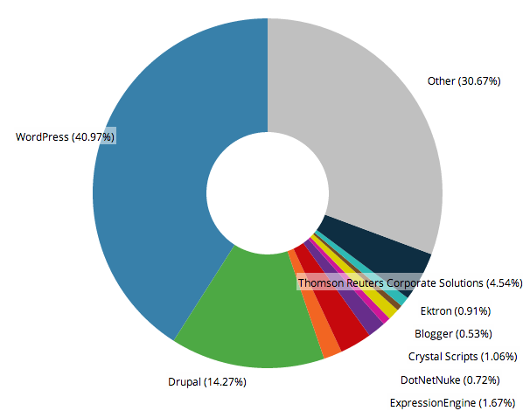

**Drupal – why it didn’t work (for this project)**Drupal was chosen as the original Content Management System (CMS) for this project. Drupal has been open source [5] since 2001. Drupal is freely downloadable online and has an active community that maintain and contribute to it. Drupal is used on a massive amount of websites worldwide. If used correctly it can offer the administrator/developer a great amount of flexibility to create custom pages/views. I used the current version of Drupal, which is Drupal 7 for the installation.

The main reasons I choose Drupal for this project are:

* It’s a CMS that I have installed on a couple of occasions and as I had heard good things about it being powerful and good for scalable websites. I decided that it was a good opportunity for me to get to understand Drupal.
* My research had indicates that it was a CMS that integrate well will with mapping libraries

I’ll start by quoting the founder of Drupal, Dries Buytaert in his keynote speech at DrupalCon[6] 2011said: “I make designers write PHP. And produce horrible code. You guys should hate me.”

When finalising my decision to use Drupal as the CMS I decided to go on one of [Drupal’s Global Training Days](https://drupal.org/learn-drupal) in March 2013. Drupal’s Global Training days are full day introductions to Drupal that are run by the Drupal community once a quarter and they aim to introduce new and beginning users to Drupal. During this day course we were introduced to Drupal and did a basic installation. I left feeling satisfied that I had successfully installed a site using Drupal but more confused than ever by nodes, views, content types, articles etc.

Taking all this on board I decided to persist with Drupal – even more determined that I would understand it and unlock the powerfulness it has. Continuing on from introduction to Drupal I decided to use video tutorials, the Drupal.org website, articles and books to continue learning about Drupal.

In general I found Drupal to be counter intuitive and that the system seems to have changed dramatically in parts over the years and versions so a lot of the information available is conflicting and confusing. I realized after some unsuccessful installs and after some attempts of trying to use Drupal without spending too much time reading all the manuals that I needed to slow down and read everything slowly and follow instructions carefully. This alone I found to be time consuming as every step needed to be carefully followed and reviewed.

Drupal uses terminology, which can be difficult for the new user to understand. The main terms, which I found tricky, were nodes and views and not being able to fully understand this was another barrier when I was trying to follow some written tutorials.

Drupal Core is Drupal out of the box. I remembered from an installation that I did previously that Drupal needs a lot of extra modules to be installed in order to use it. Over time some of these modules have been incorporated into the core installation but there are still a number that nearly all sites will require such as. Some of the most installed modules are:

[Views](https://drupal.org/project/views) – this is the most installed module in Drupal and will be incorporated to the Core for Drupal 8. Dani Nordin in his book Drupal Development Tricks for Designers (O’Reilly 2012) It’s confusing for people that are new to Drupal as there is no real explanation of views on the Drupal website except that you need views if:

* You like the default front-page view, but you find you want to sort it differently.
* You like the default taxonomy/term view, but you find you want to sort it differently; for example, alphabetically.
* You use /tracker, but you want to restrict it to posts of a certain type.
* You like the idea of the 'article' module, but it doesn't display articles the way you like.
* You want a way to display a block with the 5 most recent posts of some particular type.
* You want to provide 'unread forum posts'.
* You want a monthly archive similar to the typical Movable Type/Wordpress archives that displays a link to the in the form of "Month, YYYY (X)" where X is the number of posts that month, and displays them in a block. The links lead to a simple list of posts for that month.

There is some views documentation but they are listed with different numbers beside them and these aren’t clearly linked to the version number. The documents are very confusing if you’re new to Drupal yet as it’s the most installed module it’s important to get to grips with to unlock the full power of Drupal.

Views is the most installed module in Drupal and I perceive it to be the reason that people say Drupal is such a powerful CMS.

My first instinct was to download all these modules and put them into the folder called modules or themes as relevant. This turns out is not correct and the best place to put these files is in sites/all/themes or sites/all/modules.

The modules: Please see the appendix for a list of Drupal modules, which I investigated. Some of them were installed and downloaded.

The libraries: a lot of the people that provide video tutorials use a command line tool called Drush[7] which allows users to provide some command line scripts and once this is linked to their server the files needed for the installation will be automatically pulled over and extracted ready for installation. I attempted to install Drush but decided in order to keep things simple I decided not to use Drush, as I am only an entry-level user. Not using Drush sometimes made it confusing because if something didn’t work the way it did in the video tutorial I found I was wondering if I had installed it incorrectly or if I was using a different version or whether I had missed one of the set-up steps.

**The theme**  
After consulting with some people that have experience of using Drupal and after reading some articles and books on theming I selected [Zen](drupal.org/project/zen) as a good starter theme. I had also identified [Omega](https://drupal.org/project/omega) and [Bootstrap](https://drupal.org/project/bh_bootstrap) as potential parent themes. I would have preferred to start the theme from the beginning but as I am new to Drupal and because most of my backup reading advised using a starter theme I settled on Zen as it’s widely used and recommended for beginners - so I thought that there would be plenty of documentation to support customization of this theme.

In hindsight I wish I had paid more attention to the following paragraph from Dani Nordin’s book in his book Designing and Prototyping for Drupal (Designing and Prototyping for Drupal, O’Reilly Media, 2012) Dan had tried “Zen (*drupal.org/project/zen*) a few times before realizing that [he] couldn’t make sense of it.

He goes on to say “If you spend any time in the Drupal community, frankly, you’re going to hear a lot of people recommending Zen. In fact, it is such a common base theme that many people who start working with Drupal start out working with the Zen theme, often on the recommendation of a developer they know. As you might have guessed from my comments above, I’m not a huge fan of Zen, but I include it because you’ll probably hear about it at some point. One thing it does well is produce well-ordered code; unfortunately, it suffers from many extra <div> tags, and multiple CSS files that handle different aspects of page layout, which can be confusing for new themers.”

I started out with Zen and copied it to make the child theme. Zen as theme is quite bulky – it used to ship with a whopping 28 stylesheets! This version of Zen is bundled with 11 style sheets but half of them were redundant for this project. All in all there were four main stylesheets which I used for this project. There was a lot of code and a lot of styles to overwrite and it was confusing trying to find the right styles in the correct stylesheet. As a result styling the website took a lot longer than anticipated and ultimately I wasn’t happy with the end result. I had to re-start styling project a few times as the website wasn’t displaying properly on some browsers and for mobile. The third time I was extremely careful not to change any of the widths or anything that would break the default responsiveness however I found that the template still didn’t respond very well. I have come to the conclusion that this template although mildly responsive would have been better to start with one that had explicitly designed to be responsive form the beginning.

**Forum**

The forum module ships with the core of Drupal 7. Using the Zen theme I didn’t like the way the replies were formatted and I wasn’t successful in styling them in they way I had wanted.

**Maps**  
As the later phase of this website has a heavy focus on mapping and route creation I have done some preliminary research which I will discuss later in this report in more detail. It is generally thought that Drupal is the best free CMS to use when working with maps. Drupal has been integrating with maps since 2005.

In order so that I could better understand how Drupal and Maps work I purchased Mapping with Drupal, O’Reilly 2012 which seems to be the only available book on the topic. The IRC chatroom users also recommended this book to me. The book follows two streams – one which is uses GMap and Locations module however they didn’t offer the functionality I envisages as they couldn’t store polygons so I followed the OpenLayers and Locations Module ‘recipes’[8]. I watched a some of the [Drupalcon mapping](http://www.youtube.com/watch?v=BPXDrln0QB0) talks (this is how I first heard of the IRC chatrooms). Although for the first phase of this project maps are not a core feature I have done a lot of research so I will discuss them in more detail later on.

**Custom maps module**I followed the steps inMapping with Drupal, O’Reilly 2012 to create a custom map module however like many of the books and documentation available – the authors seem to make certain assumptions about the users knowledge which meant that I couldn’t get the module to work however I was in doubt as to whether or not that was because there had been a change in the functionality since time of writing.

**IRC chat rooms[9]**  
I found I was having problems understanding how to set up the maps and I was having some unexpected errors after following some installation steps. It was very difficult to troubleshoot these problems and after some unsuccessful attempts at searching the forums I took to [IRC](http://webchat.freenode.net/), which has various chat rooms with people online that have experience in that area. So after some more [searching](https://drupal.org/irc) I headed to #drupal-support and #drupal-geo. Although I found the people there very helpful unfortunately I didn’t resolve any of the problems I was having.

**Drupal Summary**In general I found Drupal to be very counter-intuitive and it needs a lot of modules added to the core in order for it to work reasonably well. All lot of the documentation and books seem to be out of date and I encountered unexpected errors to which I couldn’t find resolutions for –troubleshooting is very difficult for someone that’s new to Drupal. Configuration of modules was confusing at times and the modules didn’t really work in the way I wanted and most of them did not look good out of the box so needed a lot of styling – which I found tricky to do with the theme I had chosen.

Author Dani Nordin in his book Designing and Prototyping for Drupal (Designing and Prototyping for Drupal, O’Reilly Media, 2012) says if you’ve ever thought of using Drupal as a “quick” or “cheap” way to build a website, and you’ve experimented with it at all, you’ve already learned that you were dead wrong in that assumption.”

**Wordpress**For the second version of the project www.rothar.info, which had a very short turnaround time, I chose Wordpress as the CMS. I chose Wordpress because I had used it before and although there was a learning curve I found it to be a lot more intuitive. The installation of Wordpress was very quick and easy and did take less than [5 minutes as Wordpress promised](http://codex.wordpress.org/Installing_WordPress#Famous_5-Minute_Install). Adding plugins is quick and easy and plugins can be easily searched installed and activated from the backend.

**Theme**  
I started to build a responsive child theme using Responsive as the parent theme but decided as this website had a very fast turnaround time, to purchase the WP theme called [Salient](http://themeforest.net/item/salient-responsive-multipurpose-theme/4363266). Salient is a responsive theme that is meant for designers to showcase their portfolio so it looks great. I made some alterations to the theme to suit the needs of this project. It’s been relatively easy to use and I am happy with the results. I took some imagery to go with the website and this theme showcases images well. I have done some customisation to this theme and I feel comfortable that over time I can enhance this more and the theme can be adapted to fit the needs of the website as it grows.

**Modules**

**The Events Calendar**For this stage of the project I chose The Events Module. It was easy to install looks great out of the box, can manage various views, adds a pin to a map of the location and overall provides a good user experience. I customized some of the colours but generally didn’t have to change a lot. In order to enable users to add events to the calendar there is an add-on, which costs $65. At this stage I didn’t want to invest this money, as I believe that there is an alternative way to provide this functionality with no cost attached.

**Forums**I selected bbPress for the forum as it generally receives a lot of [good reviews.](http://www.makeuseof.com/tag/3-wordpress-forum-plugins/) It as easy to set up and unlike Drupal’s forum module it looks really good out the box.I was happy with the basic functionality of this and the user experience it offers users.

Some add on for this module, which I installed, and used are:

* bbP Signature: allows users to add signature
* GD bbPress Attachments: add attachments to threads and replies
* bbPress Threaded Replies: add nested functionality to bbpress

The people that wrote Wordpress wrote bbPress and overall I was very happy with this plugin.

**Responsive Design**  
In recent years the growth of mobile devices and tablets etc. that can access the Internet has grown exponentially. And although in previous years web designers could usually comfortably estimate the size of the screen which people will be using to access their website– that is no longer the case.

Both the Drupal and Wordpress versions of the site needed to has been built using a responsive theme that has been customized for this project. The design uses percentage widths and media queries. There is good support across browsers for media queries[10].

**Maps**Maps on website are generally made up of three main components. The map tiles, the mapping library and the mapping overlay - which contains the information to be shown on the map.

**Mapping library**Early on I had identified two libraries as potentials for this project. [Leaflet.js](http://leafletjs.com/) and [Openlayers.js](http://openlayers.org/). They­ are both Open Source, free to use JavaScript libraries.

They both had their pros and cons but ultimately I wanted to use the one with the most functionality and that was OpenLayers. OpenLayers has been around a lot longer than Leafleft.js so there is more documentation but that also makes it a lot bigger at around 1.4m MB v Leaflet.js which ships at a tiny 385 KB and also more complicated.

OpenLayers makes it easy to put a dynamic map in any web page. It can display map tiles and markers loaded from any source.[11] Leaflet needs to be [adapted to work with Google](http://stackoverflow.com/questions/11069082/how-to-use-google-maps-api-in-leaflet-cloudmade) Maps where Open Layers easily works which many different mapping tile services, which have different projections.

Ultimately I for the Drupal installation I chose to use OpenLayers because it offered the most functionality and I wanted this part of the website to be scalable. There is a comparison of mapping modules [here](https://drupal.org/node/1704948) and the comments on this page note that “it’s hard to use at firs but very flexible.”

**Map tiles**There are several web mapping services available[12] and each have their own licensing restrictions and benefits over each other. The libraries that I have identified that can be used for the project and these will allow the user to switch between maps. It is important that the user can switch between maps because in September 2102 over 100 million[13] Apple devices that had previously been using Google Maps in their mapping application were switched to Apple Maps. A lot of the data in Apple Maps was [incorrect](http://www.bbc.co.uk/news/technology-24246646) and users quickly lost confidence. Tim Cook the then CEO of Apple even [wrote a letter](http://www.apple.com/letter-from-tim-cook-on-maps/) to Apple users advising them to install rival companies mapping apps. Following on from this I asked a couple of friends to use OpenStreetMaps and their reaction was negative towards a ‘new’ map as they had had a bad experience with the Apple Maps so they wanted to use Google Maps only.

**Map tile servers**  
With the loss in confidence of to users to the Apple maps in general I would not built a mapping application without at least the option to switch the view to Google Maps. This is possible to do by using the correct mapping library as the library will detect what projection the map tile servers use and adjust accordingly.

Open Street Maps: Heavy use of the OSM map tile servers’ needs prior written consent however there are no actual guidelines explicating telling the usage limits. There are alternative to using the OSM tile servers such as using [MapQuest Open](http://wiki.openstreetmap.org/wiki/Mapquest#MapQuest-hosted_map_tiles) or paying for [Commercial OSM Software and Services](http://wiki.openstreetmap.org/wiki/Commercial_OSM_Software_and_Services)or setting up your own tile server which can be quite time consuming and expensive. The MapQuest hosted map tile has restrictions but generally these should be sufficient for the needs of this project in the first instance.

Google Maps is a very popular mapping application available freely online to most users (there are capacity limits beyond which it becomes a [paid service](https://developers.google.com/maps/documentation/business/faq#usage_limits)).

**Website analysis**

There are various tools available for site analysis to measure how users enter/find (search engine optimisation) and interact (user experience) with the website amongst other metrics. It is important to measure these metrics and to analyse the results so that a websites strategy can be optimised to target what users want and are looking for. Outlined below are the steps and technologies that will be taken following the launch of the website to analyse the user behavior and to develop the Search Engine Optimisation (SEO) strategy for the website.

The key tools I will discuss in this section of the report are:

* Google Analytics
* Google Webmaster Tools
* Google Adwords
* Facebook Insights
* AWStats

**Google Analytics**

Google Analytics is a free tool made available by Google for website owners and webmasters which will be used to analyse the website traffic and visitor behavior plus various other aspects of visitor behavior and conversion rates which are outlined later on. In order for the repots to be available on this tool the Webmaster needs to sign up for an analytics account and will get a unique ID for the website. Users get a unique snippet of code, which is in the form of a small piece of JavaScript, which will be inserted in to each page that is available to the users when they are visiting a website. This code has been added to the pages of both websites. Users don’t see this code and this will allow administrators users to login to the Google Analytics web portal and access the various reports available. Reports can be emailed and exported.

There are many reports in this tool that are useful for analysis but the key ones for this project are likely to be:

**Audience Overview Report**

The Audience Overview report which is a report that displays the number of visits over a specified period of time. This can be useful for identifying number of visitors, new v returning, and peak days/weeks/months for visitors. Regarding peak days/months: as this project is primarily targeted to people that will be engaging in outdoor activities it would be expected that the winter months would have less visitor activity with a peak in activity during the spring and summer months. A strategy based peak visitor behavior could be devised to attract more visitors to the website during the colder months perhaps in the form of product reviews or a blog.

**Traffic Sources**

The traffic sources report is another important report when it comes to website analysis. The Traffic Sources Overview report gives a good view of how visitors find the website and a summary of the main keywords used. There is one major issue with the Google Keyword reporting and that is there will likely be a high number of results that are listed as ‘not provided’. This is a feature which Google set a couple of years ago and means that when a user is logged into their Google account and searching using Google their search is conducted of SSL and means that it cannot be tracked by Google so this can make it tricky to know the ROI of organic keyword searches. There are some [work-arounds](http://blog.kissmetrics.com/unlock-keyword-not-provided/) for this (KissMetrics) however another workaround is to use another analytics tool called AWStats, which will be explained later.

**Demographics – Technology Report**

Importantly for a website which focuses on maps the Demographics Technology report will show what devices users are using to access the website. A later phase for this project should include a mobile application of the website which will be specifically designed for use on mobile so the first phase, although it will be responsive, will not be the optimum user experience for visitors accessing on their mobile. Having access to this report can help to shape the mobile launch phase for the website.

**Visitors Flow and Behaviour Flow**

These reports will demonstrate user behavior upon reaching the website. This can be used to measure where users are entering and what pages they visit following entry to the website. The visitor’s flow will also demonstrate the visitor flow by location showing which countries are interested in which pages. On the visitor flow report the webmaster can highlight the visitor flow by territory to see if some regions are more interested in certain content or aspects of the website.

**Site Speed**

This report gives an overview of site speed and load time, which is very important for a good user experience. Drilling down into this tool Google will also give suggestions on how to improve site speed and what might be causing your pages to load slowly in desktop and mobile along with a Page Speed Score. Obviously using this information means that the website Webmaster can improve page load times.

**Custom Reports**  
Custom reports can be put together to suit the website analysis needs. There are many filters and options for this but it is likely that the standard reports are sufficient for the needs of this project at this stage.

**Google Webmaster Tools**

Google Webmaster Tools are another set of free tools from Google that provide data and analytics to help improve site performance in Google searches. Google Webmaster Tools integrate well with Google Analytics so that the data becomes available in Search Engine Optimisation (SEO) reports. The tools help to identify landing pages on the site that have good click through rates (CTR) but might not have good average positions in search results. These could be pages that need developing.

The information from the Webmaster Tools can be used to decide which elements of the website should be focused on for particular keywords and can be used to develop and identify pages in the site that have a good click through rate (CTR) but poor position in the search results. This might mean that visitors are interested in these pages but have trouble finding them and, conversely, pages which have good keyword positioning but poor click through rates may need some attention and improved content strategy.

To enable Webmaster tools a file needs to be placed on the server where the website is stored so Google knows that it is an authorised account. A short description of some of the tools is below:

**Search Appearance**

This will show how well the pages are doing in search results.

**Data Highlighter**  
The website will provide details of local cycling groups and events. The Data Highlighter tool provides an easy user interface so that the Webmaster can highlight page patterns so that Google knows how to provide the relevant information in search results.

**HTML Improvements**

This will alert the webmaster to any issues with content on pages that the spiders find when crawling pages i.e. problematic title tags, meta descriptions etc.

**Sitemaps**

A sitemap should be submitted to Google to ensure that Google knows all the pages on the website.

**Adwords**

Another free tool provided by Google is the Google Adwords tool. Not only can this be used to track paid advert campaigns but it is also has an extremely useful keyword planner tool. This tool enables the Webmaster to plan a keyword strategy and to gauge the popularity and competition for certain keywords.

**Keyword Planner**

This allows the Webmaster to set certain parameters and see what the competition is like for these search terms. This is not only useful for websites embarking on paid advertising campaigns but also for those that just want to see the lay of the market. There are campaign bid simulators and thee tools are quite advanced and covering each step in the software is outside the scope of this report.

**Campaigns**

If an Adwords campaign was part of the project, this would be the place where budgets and campaigns can be managed. The Webmaster can use these tools to target specific locations and drill down to various other demographics.

**Facebook**

Facebook Insights can be used to measure a Facebook pages performance to find demographic data about he Facebook page audience. I have created a Facebook page, which at time of writing has 80 followers s and included a screenshot of the Insights page in the appendices.

**AWStats**AWStats is a web server analytics tool, which was designed for use by network administrators to measure traffic to a server. It is by no ways as nice to use as Google Analytics but it does offer a work around for accessing the keywords, which Google provide as ‘not provided’. As this tool sits on the server it doesn’t require a snipped of code to be added to each page. It can be used as a back up in case there is a problem with the analytics.

**SEO**

**Robots.txt**

Robots.txt is a text file that is placed on the server usually at the root level. This file will tell search engines which pages to index on a website. As this project has been built using a CMS the robots.txt file should advise the spiders not to index the admin pages or anything else, which should not show up in search engine results.

**Keyword Targeting**

An initial keyword analysis report (included in the appendices) using the Keyword Planner tool from Google. This information can form the initial SEO strategy which will be reviewed following the launch of the website. It is interesting to note that the competition is quite low for nearly all of the search terms. Using the keyword analysis report I further analysed the information by creating a pivot table and calculated the keyword repetition based on the number of times each word shows up. This will help to further develop the keyword strategy.

**User Feedback**Another way of analysing the website strategy is to ask users to directly submit feedback in the form of a web form or user testing. There are various tools available for capturing this information such as Survey Monkey or Google Docs Forms. I started to put together a Survey Monkey and found that the free account placed too many restrictions so I decided it would be better to use a Google Docs Form. I have included examples of the survey in the apendicies.

**A/B Testing**

If the goal of the website changes and the aim in to make revenue form the website, and there are significant visitor numbers - it may be useful to implement [Optimizely](https://www.optimizely.com/) on the website to conduct A/B testing. Oprimizely lets the website owner/administrator to move elements and make updated and records users behavior then compares the results. The plans for this start at £12 per month so a this stage that wouldn’t be implements however this may be something that gets implemented at a later stage.

**Conclusion on site analysis**

There are various free tools available to website administrators to track user behavior, SEO performance etc. The mains tools that will be used for this project have been discussed above but there are many more available some paid but mostly the free tools available are fit for purpose.

**Future Development Plans**

**Circular Route Planner**

**Android and iPhone Application**

**First Bicycles**

Section where people submit pictures of themselves on their first bicycles & their current bicycles. Possibly if they are based in London they could provide the picture of themselves and then I could recreate this photo as closely as possible and display the pictures side-by –side.

**Bicycle & person of the week**I have some pictures of people out and about on their bicycle. At this point I didn’t gather their name and details of their bike and why they like cycling but this could be a little bit [like the person of the week.](http://flybnight.weebly.com/2/category/fashionable%20person%20of%20the%20week/1.html)

**Reference List:**

Ethan Marcotte (2010), *Responsive Web Design*. Available at: <http://alistapart.com/article/responsive-web-design> (Accessed: September 2013).

Ethan Marcotte, Fluid Images. Available at: <http://unstoppablerobotninja.com/entry/fluid-images/> (Accessed: September 2013).

Richard Rutter (2004), *How to size text using ems. Available at:* <http://clagnut.com/blog/348/> (Accessed: September 2013).

Richard Rutter (2007), *How to Size Text in CSS*, Available at: <http://alistapart.com/article/howtosizetextincss> (Accessed: September 2013)

Erik A Meyer (2013), *CSS Fonts*, USA: O’Reilly

Jonathon Snook, Font Sizing with rem, Available at: <http://snook.ca/archives/html_and_css/font-size-with-rem> (Accessed: September 2013).

Chris Coyer (2012), *Why ems*, Available at: <http://css-tricks.com/why-ems/>

Chris Coyer, *Icon Fonts are Awesome*, Available at: <http://css-tricks.com/examples/IconFont/> (Accessed: October 2013)

Elliot Jay Stocks (2011), *CSS Transitions* <http://elliotjaystocks.com/blog/css-transitions-media-queries/> (Accessed: September 2013)

Jakob Nielson (2007), *Banner Blindness: Old and New Findings,* Available at:<http://www.nngroup.com/articles/banner-blindness-old-and-new-findings/> (Accessed: October 2013)

Dani Nordin (2012), *Drupal Development Tricks for Designers*, USA: O’Reilly

Dani Nordin (2012), *Drupal for Designers*, USA: O’Reilly

Alan Palazzolo & Thomas Turnbull (2012), *Mapping with Drupal*, USA: O’Reilly

Angela Byron & Addison Berry with Bruno De Bondt (2012) *Using Drupal (second edition),* USA: O’Reilly

Angela Byron, Addison Berry, Nathan Haug, Jeff Eaton, James Walker & Jeff Robins (2009), *Using Drupal,* USA: O’Reilly

Ric Shreves (2011), *Drupal 7 Themes*, Birmingham: Packt Publishing

Erik Hazzard (2011), *OpenLayers 2.10*, Birmingham: Packt Publishing

Bicycle Retailer (2012), *Fitness apps storm cycling* <http://www.bicycleretailer.com/north-america/2012/06/07/fitness-apps-storm-cycling#.UlGSzWRAR60>

Kasia Mikoluk (2013), *Drupal v Joomla v Wordpress*, <https://www.udemy.com/blog/drupal-vs-joomla-vs-wordpress/>

Andrew Montgomery (2013), *Best cycle app: Strava or MapMyRide?,* <http://grimpeurheureux.com/best-cycle-app-strava-or-mapmyride/>

Tom Vanderbelt (2013), *How Strava is Changing the Way we Ride,* <http://www.outsideonline.com/fitness/biking/How-Strava-Is-Changing-the-Way-We-Ride.html>

Claire Broadley, *How to Unlock Your ‘Not Provided’ Keywords in Google Analytics,* <http://blog.kissmetrics.com/unlock-keyword-not-provided/>

<http://blog.hubspot.com/blog/tabid/6307/bid/33164/6-SEO-Tools-to-Analyze-Your-Site-Like-Google-Does.aspx>

Andrew Searles (2013), *Designing in the Browser*, <http://andysearles.com/designing-in-the-browser/>

Amanda Luker (2011), *Designing for Drupal: Dos and don’ts,* <http://www.advomatic.com/blogs/amanda-luker/designing-drupal-dos-and-donts>

1. <http://newsle.com/article/0/72690928/>
2. <http://about.mapmyfitness.com/about/company-history/>
3. A "tileset" typically includes enough map tiles (images of sections of a map) to form a very large image, if they were shown all at once, and also several zoom levels. Source: <http://wiki.openstreetmap.org/wiki/Tiles>
4. Modernizr.js is a JavaScript library that detects support for HTML5 and CSS3 features in the user’s browser.
5. [Open-source software (OSS)](http://en.wikipedia.org/wiki/Open-source_software) is computer software with its source code made available and licensed with a license in which the copyright holder provides the rights to study, change and distribute the software to anyone and for any purpose.
6. Drupalcon is a bi-annual, week long conference for Drupal developers
7. Drush is a command-line shell and scripting interface for Drupal, designed to make life easier for those who spend their working hours hacking away at the command prompt. <https://github.com/drush-ops/drush>
8. A recipe is a set of steps to follow which will result in a finished product
9. Internet Relay Chat (IRC) is a protocol for live interactive Internet text messaging (chat) (Source: Wikipedia)
10. According to <http://caniuse.com/> 85.42% of browsers support media queries
11. Source: http://openlayers.org/
12. <http://en.wikipedia.org/wiki/Comparison_of_web_map_services> & <http://www.tile5.org/javascript-mapping-libraries>
13. <http://www.apple.com/letter-from-tim-cook-on-maps/>